壹：聽力測驗
一、請選出你所聽的單字：10％
1. life like living
2. day week month
3. jacket pants sweater
4. happy funny worry
5. stupid study show

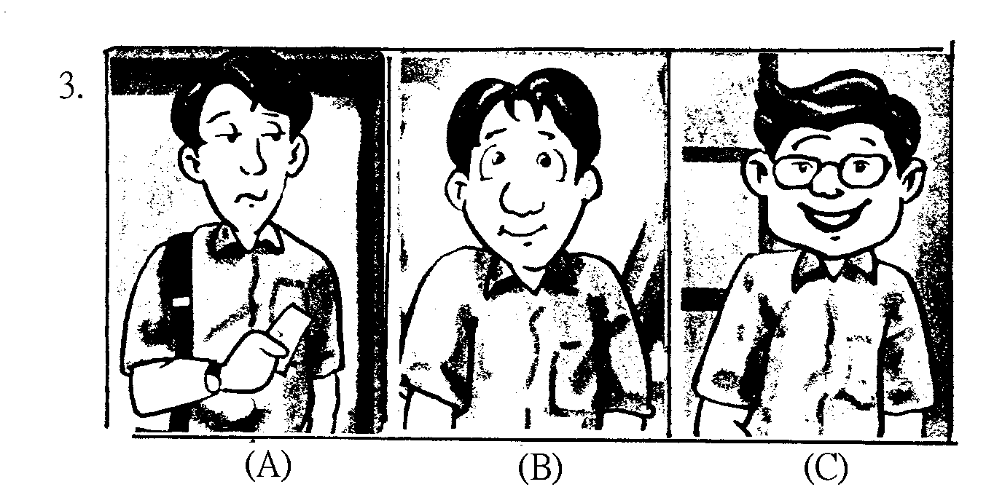
二、請聽老師所唸的句子，選出正確的圖片代號：10％
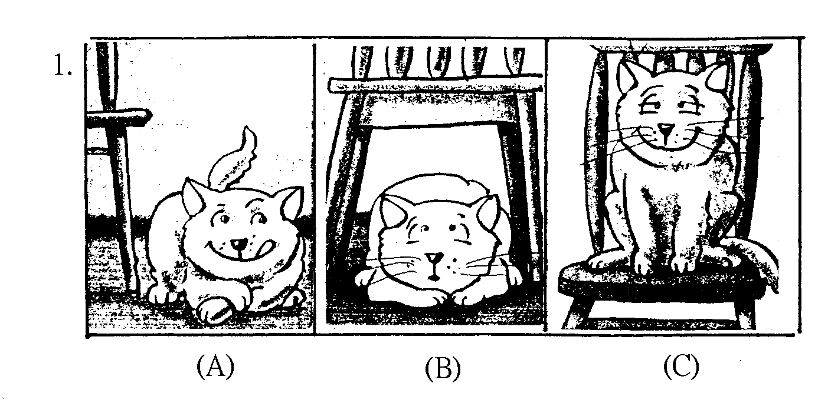
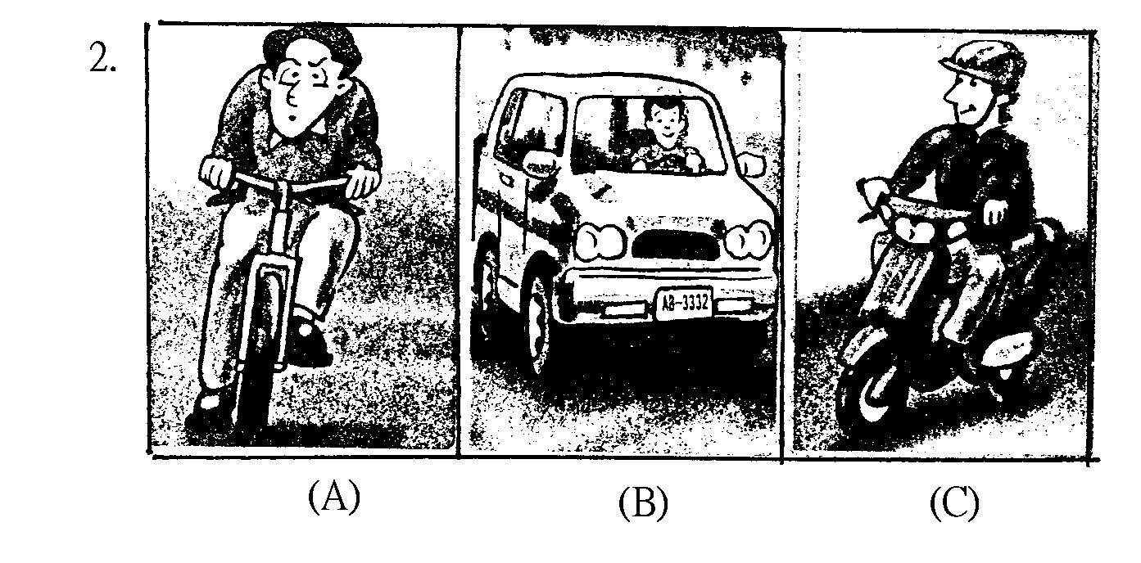

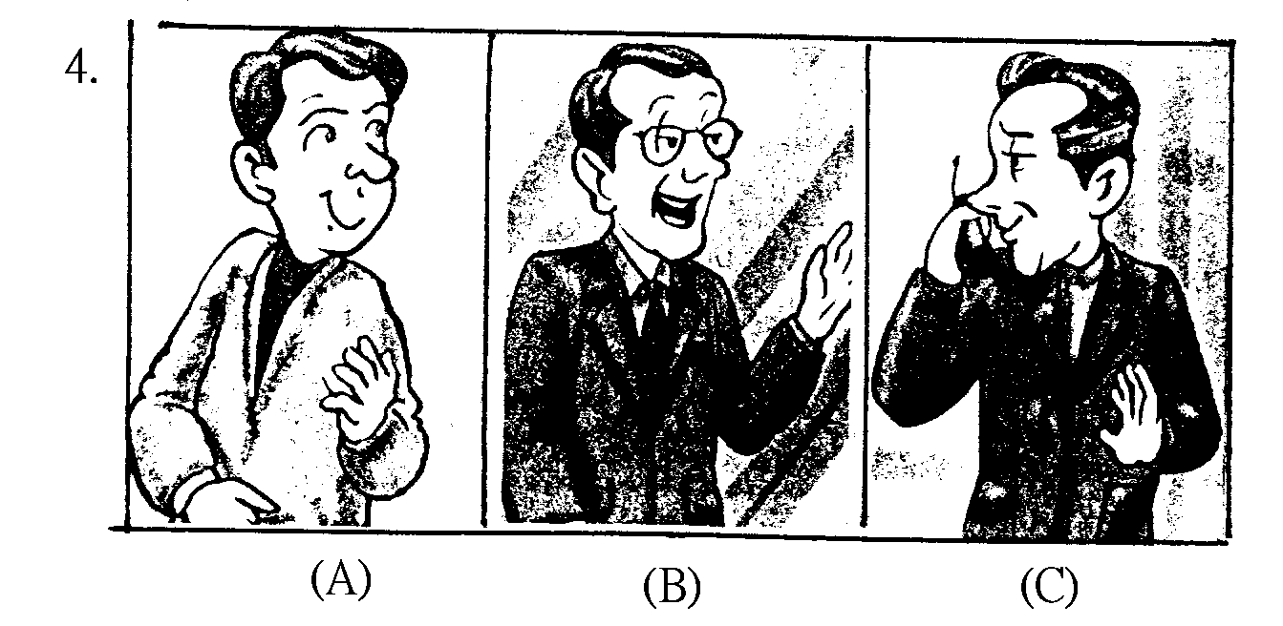
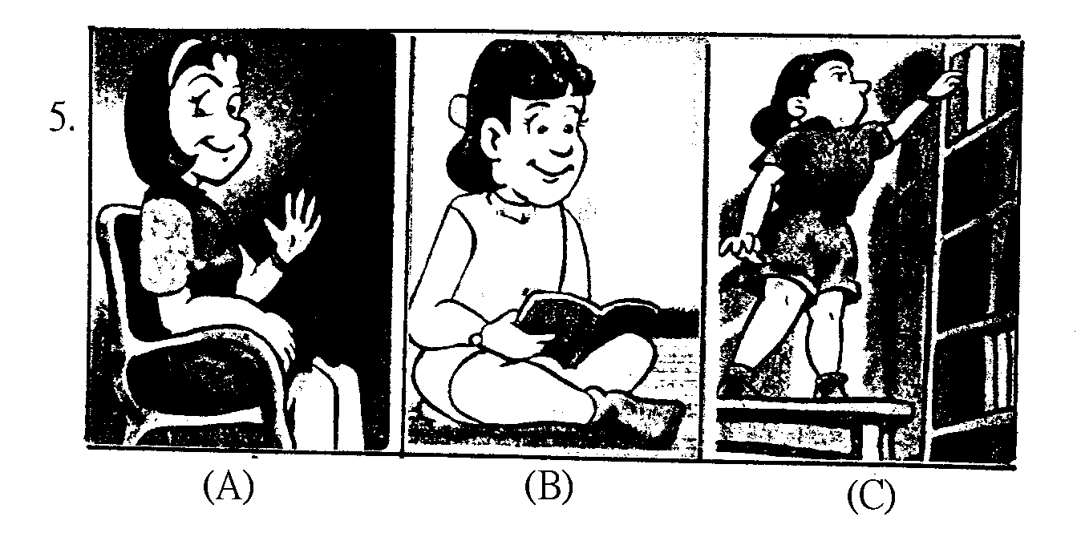

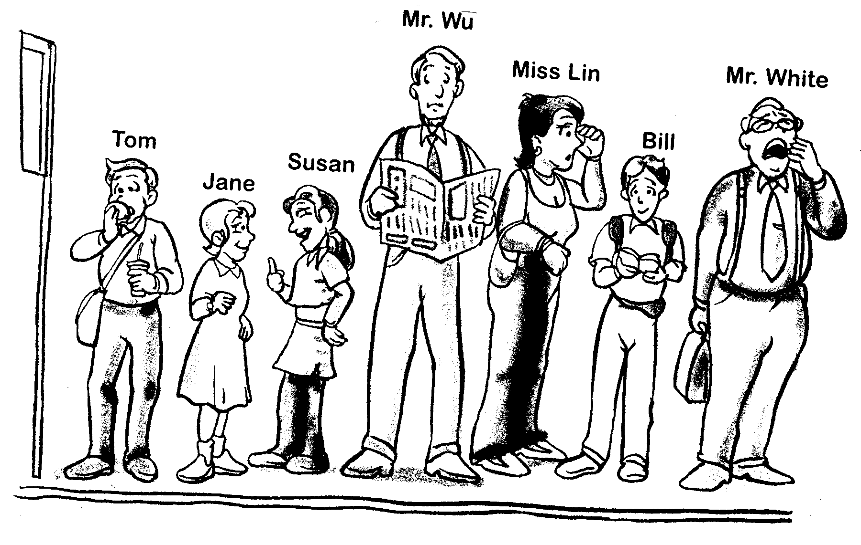

三、請聽老師所唸的句子，看圖找出符合該敘述的人，
並寫下他們的名字10％
1.
2.
3.
4.
5.

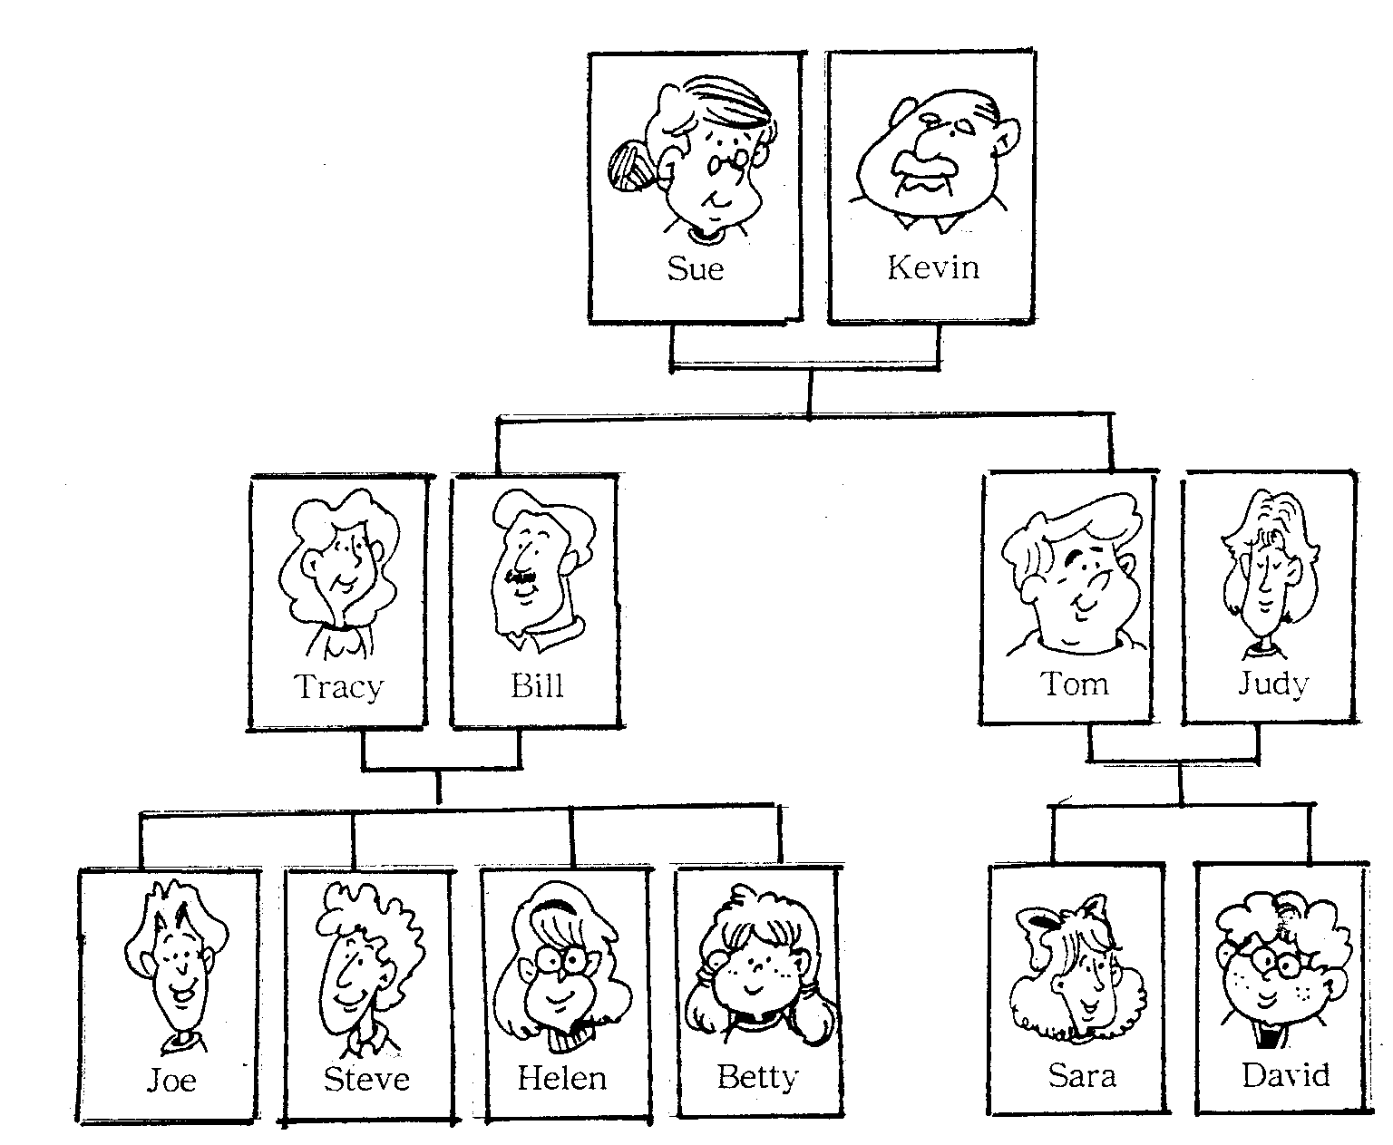
四、是非題：請聽錄音帶的敘述配合family tree，敘述
正確者填T，錯誤者填F：10％

1.
2.
3.
4.
5.

貳：綜合測驗
一、文意選擇：20％
Ａ：Eric ：Excuse me. Is this seat 1. ？
Ms. Wu：No, it isn’t.
Eric ：Nice weather, 2. it？
Ms. Wu：Yes. It’s been cold 3. so many days.
Eric ：Yeah, this is my first time to jog this week. Look at my jogging shoes. I bought them
4. Hong Kong. They’re really nice.
Ms. Wu：Well, I……
Eric ：Look at those men. They’re walking, not jogging.
Ms. Wu：Who are you talking about？
Eric ：The man 5. a funny hat.
Ms. Wu：Oh, that’s my brother.
Eric ：Oh, sorry. I mean the man in the black pants.
Ms. Wu：Well！ He is a PE teacher. And by the way, he’s my husband.
（ ）1.take taken took taking
（ ）2.is does isn’t doesn’t
（ ）3.for in about with
（ ）4.for in about with
（ ）5.in about from with

Ｂ： We can learn a 1. from the dialogue we just studied. The man in the dialogue was quite polite 2. he began to talk with Ms. Liu. But when he talked about the 3. he liked, he didn’t notice that the woman had no interest in it. Then he started to show off.
4. of all, he criticized people. But he didn’t know the 5. he criticized was Ms. Liu’s husband！
（ ）1.class thing lesson subject
（ ）2.before when after since
（ ）3.men movies books sport
（ ）4.Most After Worst One
（ ）5.woman person people men

二、文法選擇：10％
1. The man（with wears in has）black looks so cool.
2. Who’s the one（with has in wears）the longest hair in your class？
3. I want an（33-inch 18-inch 80-inches 35-inches）color TV.
4. The man you are talking about（him her X whom）is a PE teacher.
5. We should remember that computers are just machines（that we use who we use when we use which is used by us）

三、釋義及閱讀測驗：10％
1. “Baseball is my life”, said Tom.
Tom hates baseball very much. Baseball is the most important thing in Tom’s life.
Tom makes money by playing baseball. Tom has never seen baseball in his life.
2. The doctor Peter is talking to is my father.
My father tells me that Peter is a doctor. The doctor is Peter’s father .
Peter is talking to my father. My father is talking to the doctor.

On my birthday this year, my father bought me a new computer. The computer is an IBM586, and it came with Windows-98. It runs very fast and is very useful.
Now I write my English homework on it. When I learn some new words or phrases（片語）, I type them on the computer. I also use a Chinese program（程式）. Besides, I can work on the computer while a CD is playing on it. I really enjoy using my new computer！
In the modern world computers have entered our lives. Stores, schools, and factories need them. We cannot live without them. We have to use them to keep up with the times, or we will fall behind. Computers have already changed our world！
（ ）3. What does a computer help the writer do？
His computer homework. Write letters. Play games. His English homework.
（ ）4. What language(s) can the writer write in when he uses his computer？
Only English. Only Chinese. English and Chinese. Amy language he likes.
（ ）5. Why does the writer think that computers have entered our lives？
All kinds of businesses use computers now.
Computers help people think faster.
People have forgotten how to write letters by hand.
Everyone he knows has one.

四、填入適當的關係代名詞who或which：５％
- Children play the piano every day concentrate better.
- Grandfather is the man I love most in the world.
- Taipei is a city has about three million people.
- This is the hospital John’s father went to last month.
- Tom wrote a story was about an old man and a child.

五、中譯英：15％
1. 炫燿是不禮貌的。
2. 爸爸買的手機真有用。
3. 懂得談話藝術的老師受歡迎。
4. 世界就像個小村莊。
5. 我喜歡那部叫做鐵達尼號（Titanic）的電影。
答 案 卷
壹：聽力測驗
一、請選出你所聽的單字：10％
1. 2. 3. 4. 5.

二、請聽老師所唸的句子，選出正確的圖片代號：10％
1. 2. 3. 4. 5.

三、請聽老師所唸的句子，看圖找出符合該敘述的人，並寫下他們的名字10％
1. 2. 3. 4. 5.

四、是非題：請聽錄音帶的敘述配合family tree，述正確者填T，錯誤者填F：10％
1. 2. 3. 4. 5.

貳：綜合測驗
一、文意選擇：20％
Ａ：1. 2. 3. 4. 5.
Ｂ：1. 2. 3. 4. 5.

二、文法選擇：10％
1. 2. 3. 4. 5.

三、釋義及閱讀測驗：10％
1. 2. 3. 4. 5.

四、填入適當的關係代名詞who或which：５％
1. 2. 3. 4. 5.

五、中譯英：15％
1.
2.
3.
4.
5.

