台南市立民德國民中學八十八學年度第二次成績考查英語科試題
二年 班 座號 : 姓名 :
- 聽力測驗: 每題連續聽兩次(每題二分) 20%
- 聽錄音帶的敘述，在空格內圈選 (O)適當的圖片:
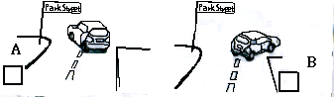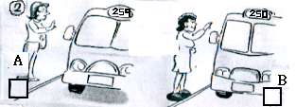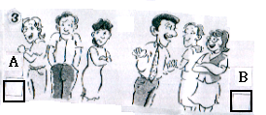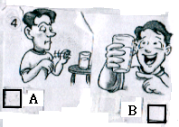
(二)錄音帶中每題有三個選項 (a , b , c ),請選出能正確描述圖片內容的句子, 將代號 (a , b , 或c )填入空格中:
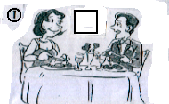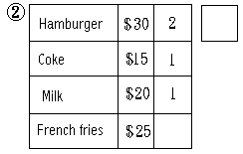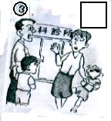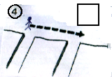
(三).聽錄音帶的對話，將下列商品的價格填在標籤上:
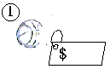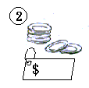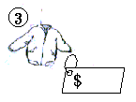
- 文意字彙: 根據句意寫出一適合文意的字 20%
1. There are three c at that 7-ELEVEN.
2. Mrs. Wang s much money on the dresses yesterday.
3. My mother buys a lot of food in the s every Sunday.
4. Can I have a to drink? I’m so thirsty.
5. Sally was sick. She went to see a d and took some m .
6. The boy was really hungry and he ate ten h .
7. The f day of the week is Thursday.
8. D s can tell you how to use (使用) a word.
9. He got two tickets and w for his girlfriend.
- 對話: 選出合乎文意的選項 6%
1. A: Hi, can I help you? B:╴╴╴╴╴╴╴╴╴╴╴╴╴╴╴╴
- You’re nice. (2) That’s OK. (3) No, I like beef. (4) Yes, five cakes, please.
2. A: What about taking a trip to Kenting? B: ╴╴╴╴╴╴╴╴╴╴╴╴╴╴╴╴
- Have a good time. (2) That’s good. (3) Can you go? (4) I had no money.
3. A: Here’s $ 1,000. B: Thank you. ╴╴╴╴╴╴╴╴╴╴╴╴╴╴╴╴
(1) Here’s your change. (2) I don’t like the change. (3) Where’s the change? (4) You have much change.
四. 先讀一遍全文，再填入適當的代名詞: 7%
Yesterday was my birthday. On , my friends gave a watch and I said thanks to . I liked ╴╴╴very much. My brother and I loved baseball, so my friends played basketball with in the afternoon. What about Bill? Does have a good time on birthday?
五.有一天Stella想和同學去體育館看籃球賽，不知道怎麼去，於是向路人問路。請參考下圖完成對話 ( Stella 在X位置) 13%【背面有題】
Stella: me, can I to the gym?
Woman: You can go First Street blocks and turn on Youth Road.
Stella: On Market Road?
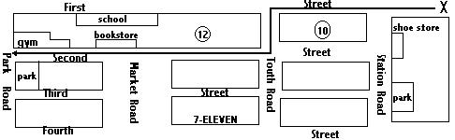Woman: , on Youth Road. (T) go one block and turn . There’s a near the gym. The gym is on the .
Stella: Thanks very . Woman: You’re .
六. 依每題括弧內的提示作答：(每題二分，全對給分)8%
- Jim did some homework last afternoon. (改為否定句)
╴╴╴╴╴╴╴╴╴╴╴╴╴╴╴╴╴╴╴╴╴╴╴╴╴╴╴╴╴
- Mom usually has a lot of milk and bread. (造原問句)
╴╴╴╴╴╴╴╴╴╴╴╴╴╴╴╴╴╴╴╴╴╴╴╴╴╴╴╴╴
- My brother rode his bike to the music store. (造原問句)
╴╴╴╴╴╴╴╴╴╴╴╴╴╴╴╴╴╴╴╴╴╴╴╴╴╴╴╴╴
4. The weather was bad. (用連接詞將二句合併成一句)
We didn’t go to the mountains.
╴╴╴╴╴╴╴╴╴╴╴╴╴╴╴╴╴╴╴╴╴╴╴╴╴╴╴╴╴
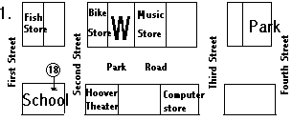七. 看圖作答：以完整句子回答 (每題二分，全對給分)10%
1. (1) Where is the park?
╴╴╴╴╴╴╴╴╴╴╴╴╴╴╴╴╴╴╴╴╴╴╴╴╴╴╴╴
(2) Where’s McDonald’s?
╴╴╴╴╴╴╴╴╴╴╴╴╴╴╴╴╴╴╴╴╴╴╴╴╴╴╴╴
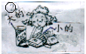 (3) Where can you take bus number 18?
╴╴╴╴╴╴╴╴╴╴╴╴╴╴╴╴╴╴╴╴╴╴╴╴╴╴╴╴
2. What did Mrs. Lin buy two days ago?
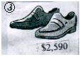╴╴╴╴╴╴╴╴╴╴╴╴╴╴╴╴╴╴╴╴╴╴╴╴╴╴╴╴╴
3. How much are the shoes?
╴╴╴╴╴╴╴╴╴╴╴╴╴╴╴╴╴╴╴╴╴╴╴╴╴╴╴╴╴
八. 連貫式翻譯: 16% (錯一處扣一分)
- 十一月三日那天，我和家人在那家餐廳享用大餐。(On . . .)
╴╴╴╴╴╴╴╴╴╴╴╴╴╴╴╴╴╴╴╴╴╴╴╴╴╴╴╴╴
- 我們非常喜歡那裡的牛排，且吃了不少美味甜點。
╴╴╴╴╴╴╴╴╴╴╴╴╴╴╴╴╴╴╴╴╴╴╴╴╴╴╴╴╴
- 晚餐後，我爸媽帶我們去火車站旁的百貨公司。
╴╴╴╴╴╴╴╴╴╴╴╴╴╴╴╴╴╴╴╴╴╴╴╴╴╴╴╴╴
- 然後，我們走到胡佛電影院看了一部很棒的電影。
╴╴╴╴╴╴╴╴╴╴╴╴╴╴╴╴╴╴╴╴╴╴╴╴╴╴╴╴╴

