1.本學科試題含題目卷四張八面及答案卡一張。
2.本測驗共55題，第1-15題為聽力測驗，請依CD指示作答；第16-55題為綜合測驗，請依題目指示作答。試題全部皆為單一選擇題。試題答錯，一律不倒扣。
3.作答時必須使用2B黑色鉛筆，將正確答案畫記在規定的答案卡上，塗改部分請保持整潔乾淨，模糊難以理解一律不計分。
4.本試題紙空白處，可供草稿使用，答案卡絕對不可打草稿。
5.本學科試卷選擇題55題，合計100分。

第一部分：聽力測驗 (20%)

一、根據聽到的句子選出最適當的回應句 (5題，第1-5題，每題1分，共5分)
( )01. I watched a great movie.
I saw a dog running after Jim.
I couldn’t see you.
I see. It sounds great.
( )02. Yes, David does it most carefully.
David is always a careful student.
Who else? Peter does.
Mr. Lin makes us do it carefully.
( )03.0 Let’s have a talk about the high price.
Perhaps you should go to see the doctor.
Today is your day.
It is very cold. Let’s go home.
背面尚有試題，請翻頁繼續作答
( )04. I will ride a bike along the beach.
The sun will set soon.
I played basketball.
Do the work more quickly.
( )05. You will concentrate more in class.
You will have to stay up late.
You will listen to your body.
You will hurt your health.

二、根據聽到的對話或敘述，選出正確的答案 (5題，第6-10題，每題1分，共5分)
For question 6 and 7, please listen to the first reading.
( )06. 1:00 a.m. 11:00 p.m. 1:00 p.m. 11:00 a.m.
( )07. Stay up. Eat fruit, jog, and drink water.
Get sick. Go to bed late.

For question 8 and 9, please listen to the second reading.
( )08. In the car. At home. In the mountains. In the air.
( )09. They forgot to bring their cellphones with them.
They feel very tired of the rain.
They hate to see a rainbow.
They are all wet.
For question 10, please listen to the third dialogue.
( )010. He is good at telling stories.
His dream of being a basketball player couldn’t come true.
He was a basketball coach when he was young.
He hurt his knees and couldn’t play basketball anymore.

三、根據聽到的文章及問題，選出最適當的答案 (5題，第11-15題，每題2分，共10分)
( )011. Watch flowers. Watch birds.
Take pictures. Cook meals.
( )012. One. Two. Three. Four.
( )013. A businessman. A teacher. A cook. A driver.
( )014. Ugly. Common. Strange. Excellent.
( )015. 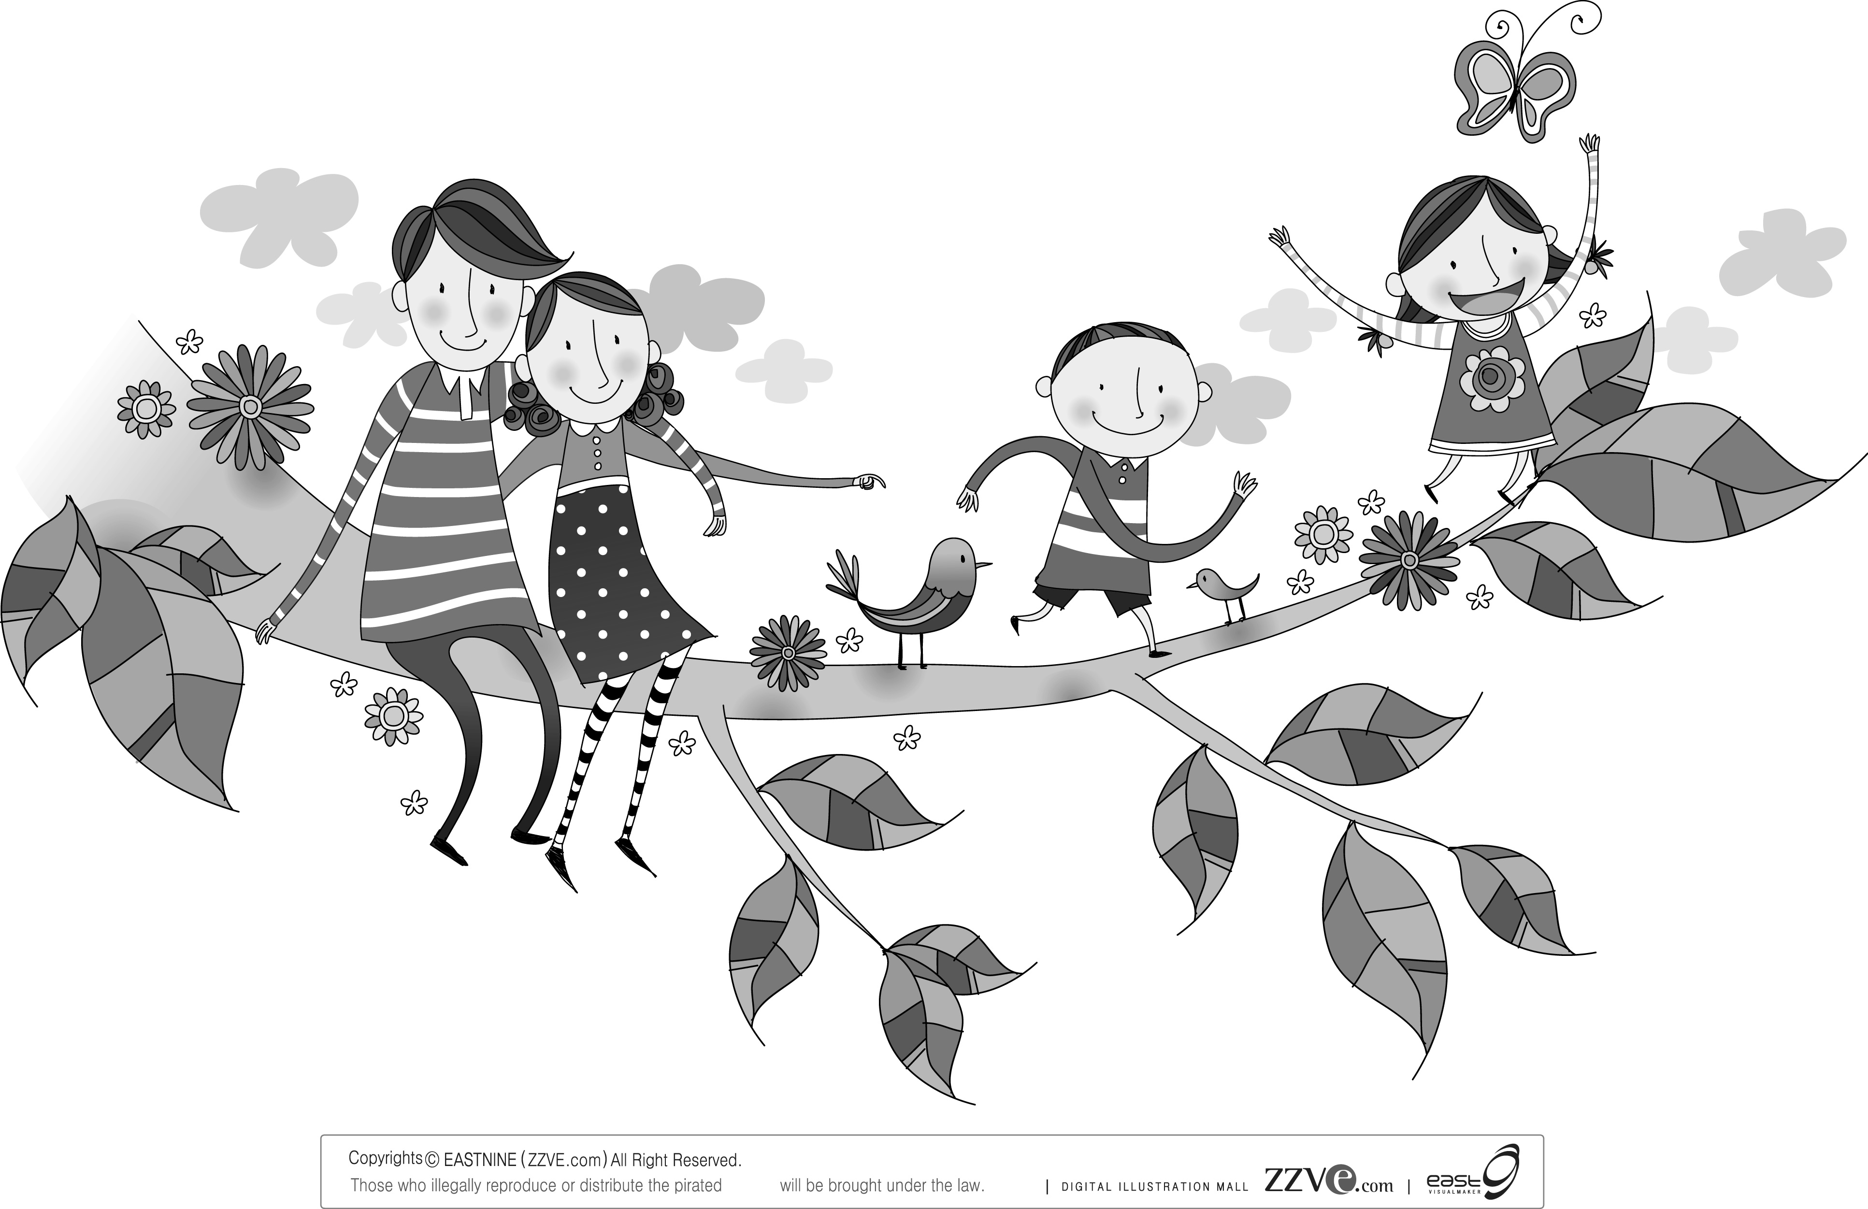 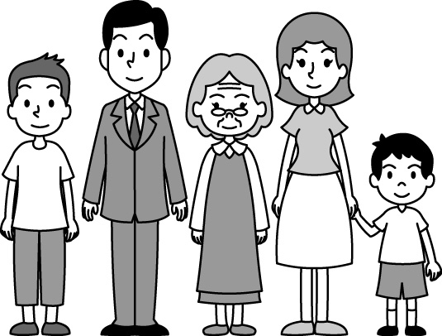
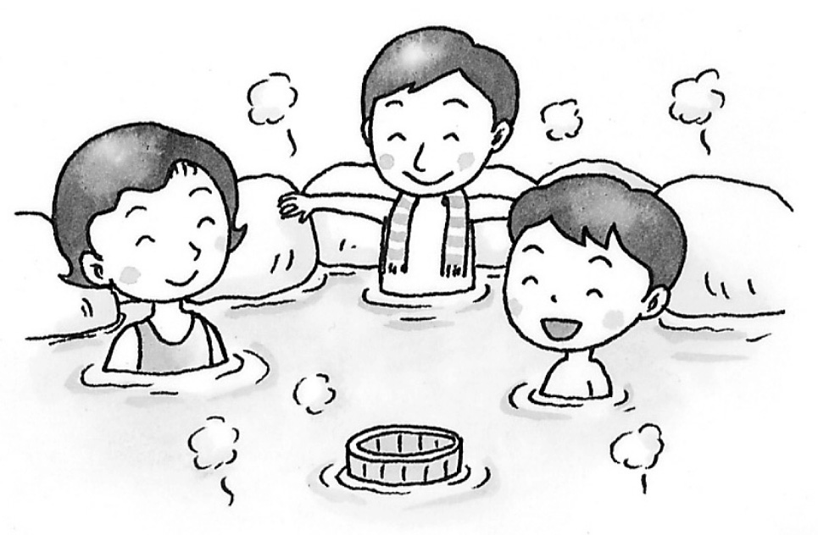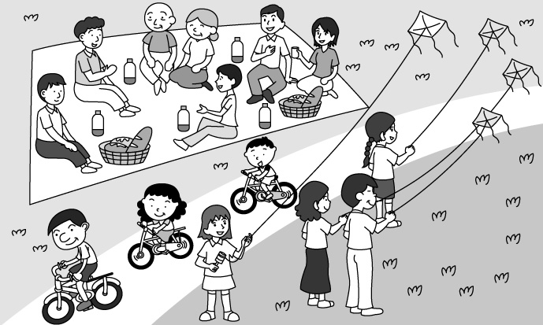

背面尚有試題，請翻頁繼續作答

第二部分: 綜合測驗 (80%)

四、語法選擇 (19題，第16-34題，每題2分，共38分)
( )016. The dog tried very hard to swim to the other of the river.
tip bank side inside
( )017. The lake is very . We can see fish in it.
safe clear giant sharp
( )018. Those man kept riding a bike along the road without . They’re really strong.
breaking rising any rest leaving
( )019. Terry: I have a bad cold. My mom doesn’t me to go out and play.
Larry: Poor you! I hope you can get well soon.
set have make want
( )020. Sam: Did you get her ?
Andy: No, I didn’t. I couldn’t understand her at all.
answer habit point mark
( )021. Before the cake, he out the candles.
cuts; blows cutting; blew will cut; will blow cut; blew
( )022. His right knee a lot yesterday after he beat the drums so hard.
hurt hurted hurts got hurt
( )023. I peek at others’ answers during the exam if the teacher gave me a second chance.
never will never would not can never
( )024. Each of the boys and girls their new seat in the new school year. Everyone can find the name and seat on the blackboard.
are having had has have
( )025. your lessons every day help you learn more and better.
Reviewing Previewing and reviewing
Preview and review To preview and review
( )026. Sandy: Why do you usually stay up late computer games, Eason?
Eason: Because I have to do homework, eat dinner, and date my girlfriend after work. I
don’t have time. Do you mind quiet? I’m busy the boss now.
Sandy: Date your girlfriend? Isn’t your girlfriend me?
Eason: Oops!
playing; to keep; fighting playing; to keep; fighting
to play; keeping; to fight playing; keeping; fighting
( )027. Wow! On the dining tables are pizzas, fried chicken, tomato soup, beef stew, and roast duck. the food looks so delicious. I love this potluck party.
All of Any of Some of One of
背面尚有試題，請翻頁繼續作答
( )028. Debby put some sugar and cream in her coffee to make it better.
tasting tasted to taste ╳
( )029. Henry when we listened to Mary a ghost story on our camping trip.
背面尚有試題，請翻頁繼續作答
shake; speaking shook; tell was shaking; saying shaking; telling
( )030. Of the two sailors, Leo is able to sail away from the big wave. I really enjoy the TV program.
the farther the farthest farther further
( )031. They couldn’t prepare for the welcome party because they were too busy. They decide go to the supermarket some food and drinks this evening. Other students would help them do it.
to; buying to; to buy not to; to buy not to; buying
( )032. Dad: Are you going out? It’s really late now.
背面尚有試題，請翻頁繼續作答
Michell: I know, but it’s the last day to buy tickets to the World Cup games, I must
go.
if or so though
( )033. Alice: Don’t you like the movie, MIB 3? Will Smith is so handsome!
May: Uh… But the story is boring.
Alice:
Give it a second chance. Look it up again.
You did a good job. I noticed that.
( )034. Mary: Honey, I’m so tired. My eyes are sore now.
Tony: Come over here. Let me take a look.
Today isn’t your day! What’s the matter?
You did a good job. I think so too.

五、克漏字選擇 (10題，第35-44題，每題2分，共20分)
(35-37題)
背面尚有試題，請翻頁繼續作答
Tiffany: Herena, how did you feel about the typhoon last week?
Herena: I felt terrible (35) .
Tiffany: Don’t worry. There are usually some typhoons coming to Taiwan in summer.
Herena: No wonder. I saw lots of trees (36) on the road this morning.
Tiffany: The city government will have people move them away in one or two days.
Herena: I see. By the way, when it (37) heavily, what were you doing?
Tiffany: I was playing basketball.
Herena: What? On a typhoon night?
Tiffany: On the computer. It’s only an online game.
Herena: I see.

typhoon 颱風 city government 市政府 online 線上

( )035. after the rain stopped before the car hit me
if it would be fine when the wind blew hard
( )036. fall was falling falls fell
( )037. will rain rained was raining rains
背面尚有試題，請翻頁繼續作答

(38-39題)
Ken, Jimmy, and Andy got lost at the beach. They felt thirsty and hungry, but they didn’t know what to do. In the meantime, they heard someone (38) , “Help! Help!” They looked around and tried to find what happened. They found a teapot near the rock. Ken kicked it.
Suddenly, a man came out of it. He said, “Thanks for your help and I’ll give each of you a wish.” Jimmy said, “I miss my family. I want to go home.” Then Jimmy disappeared. Andy said, “I miss my home, too.” Then, Andy disappeared, too. It was Ken’s turn. He said, “Now I feel lonely. I miss my friends, Jimmy and Andy.” After that, (39) of them came back.

teapot 茶壺 kick 踢 wish 願望 disappear 消失 miss想念

( )038. shouts out shouted out to shout out shouting out
( )039. all three both two

(40-44題)
Jenny needed a new pair of jeans. Her old jeans (40) too small. She went to the jeans store yesterday. She first took a look around the store. Then she chose five pairs of blue jeans and three pairs of black jeans. She tried on (41) of them, one by one. All of the blue ones were too big. One pair of the black jeans was too short, another was too small, but (42) pair was just the right size. Jenny spent a whole hour trying on the eight pairs of jeans, but it only (43) her a second to decide which to buy. The jeans cost NT$3,600. They were very expensive but they looked really
(44) on her.

( )040. is looks was were
( )041. all one two both
( )042. another other the other third
( )043. spent took cost spends
( )044. good well nicely better

六、閱讀測驗 (11題，第45-55題，每題2分，共22分)
(45-46題)
Here is the food pyramid. It groups six different foods and shows what food is good for our health in a day.

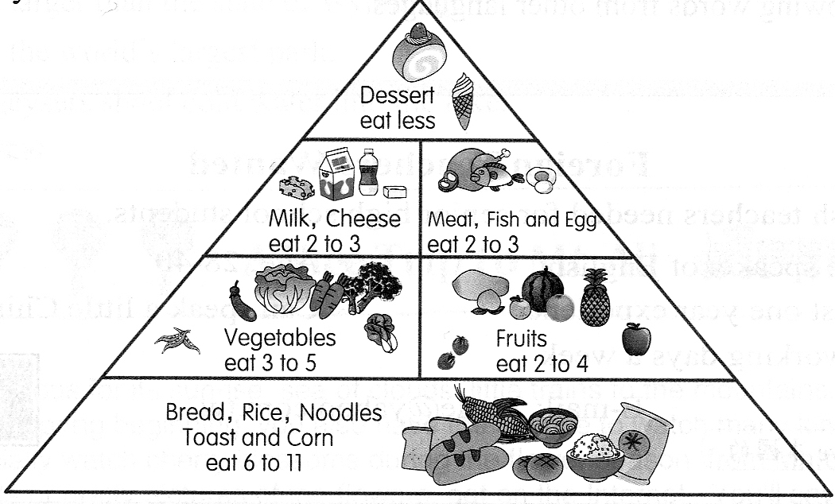

pyramid 金字塔 dessert 甜點 corn 穀物

( )045. If you want to keep healthy, what should you eat less?
Milk Tea. Fish. Ice cream. Fruit.
( )046. Which is true?
The food at the top of the pyramid is good for our health.
calory 卡路里
The vegetables have the most calories.
You can never eat meat if you don’t want to be fat.
Rice is at the lowest part of the pyramid.

(47-48題)
Here is the self-help for several cases. After reading them, answer the questions.
CASE 1: If you are burned, cool the burned part at once. Run cool water over the burn until it is less painful. Put a piece of dry clean cloth over it.
CASE 2: If the person has stopped breathing, you must try to start his / her breathing again at once. The best thing is to use the mouth-to-mouth way. Lay the person on his / her back and breathe into his / her mouth.
CASE 3: If there is a fire, never use a lift in the building because it’s very dangerous. The lift may stop between floors. Use the stairs and leave the building at once.

burn 燒 self-help 自救 painful 痛苦的 cloth布 breathe 呼吸 lift 電梯
背面尚有試題，請翻頁繼續作答

( )047. Which picture can show the meaning of CASE 2?
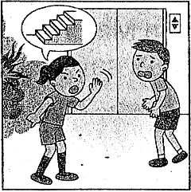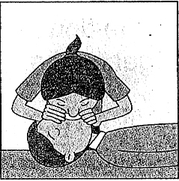
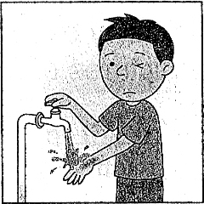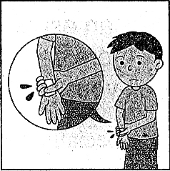
( )048. Which is true about the reading?
Don’t use the lift when there is a fire.
If you get burned, you have to run hot water over the burn.
The self-help for any case is not really important.
Before using the mouth-to-mouth way to save someone, you have to think it over
carefully.

(49-50題)
The Formosan Rock Monkey has lived in Taiwan longer than any people. Girl monkeys ask boys out. Girl monkeys tell boys what to do. Formosan Rock Monkeys think it’s fun to be bad. That’s why parents call their children “monkey kids” when they are naughty.
Rock Monkeys love climbing trees, finding food, and sleeping. They like cleaning their friends’ hair. Boy monkeys fight to be the king. If they lose, they have to leave the family.
The Rock Monkey has a red face, dark hair and a long tail. Girl monkeys take care of their babies until they are big. They shake the trees and make lous noises to make everyone stay away.
People took Formosan Rock Monkeys to be pets. Now they are going back into a place with many trees. The monkeys are clever. They find it easy to change. They look healthier and stronger. There are many monkeys in Taroko Park. You can also see them at Taipei Zoo.

背面尚有試題，請翻頁繼續作答
ask…out 約…出去約會 naughty 頑皮的 clever 聰穎的

( )049. Who can be a monkey kid?
Gaga. She doesn’t listen to her teacher. Katy. She likes to play with monkeys.
Justin. He looks like a monkey. Jesse. He doesn’t like his parents.
( )050. Which is NOT true about this reading?
Boy monkeys fight to be the king. They have to leave the family if they lose.
Rock Monkeys love sleeping and climbing trees.
We can see Rock monkeys in Taroko National Park.
Boy monkeys sometimes ask girl monkeys out.

(51-53題)
Most parents and teachers teach kids to work hard. However, working too hard might not be a good idea. Some people even work to death.
These people work very late for days and usually have less than four hours’ sleep a day. They always feel very tired and often have a headache or sore muscles. Although they are tired, they have difficulty falling asleep. Then they find it hard for them to concentrate and remember things. These are some warnings from their body, but still, these warnings don’t stop them from working so hard. Finally, their body cannot bear it any longer and they die suddenly.
According to a survey, many students in Taiwan went to bed very late. Not all of them stay up to study. Many just spend time on the Net, going through interesting websites, chat, or play games on the Net. This worries their parents and teachers a lot. If these students know what they will pay for their lack of sleep, they’ll go to bed earlier.

difficulty 困難 warning 警告 bear 忍受 according to 根據 survey 調查 lack 缺少

( )051. When one works too hard and lacks sleep, what is NOT a warning from his body?
A headache.
Sore muscles.
Have difficulty remembering things.
Sleeping during the day.
( )052. What does it mean?
Feeling tired.
To fall asleep.
To concentrate and remember things.
Staying up to work.
( )053. According to the survey, what is a problem of students in Taiwan?
They study too hard.
They can’t concentrate in class.
They don’t get enough sleep.
They spend too much time playing online games and surfing the Net.
背面尚有試題，請翻頁繼續作答
(54-55題)
Our nose and ears are important body parts. They are also used in many English expressions.
Some people are able to lead other people by the nose. For example, if a wife leads her husband by the nose, she makes him do whatever she wants him to do.
In a school, some students thumb their nose at their teacher. They say no to whatever their teachers tell them to do, like homework. Maybe these students don’t know the correct answers. If that’s the case, they should study hard and be all ears in class. This way, they are sure to understand their teachers and learn better.
The last expression is to play it by ear. This has two meanings. One is to play a song on a musical instrument by remembering the tune and not by reading the music. Play it by ear also means to decide what to do at the last minute and not make detailed plans.

expression 表達 whatever 無論何事 thumb 大拇指 musical insturment 樂器 tune 曲調 detailed 詳細的

( )054. What does “be all ears” mean?
To listen carefully.
To remember correctly.
To talk about a problem.
To get an idea about something.
( )055. Which expression will we use to talk about a person if he can make people listen to him?
Play it by ears.
Be all ears.
Thumb one’s ears.
Lead someone by the nose.

Tips
※Keep this in mind: check carefully again and again before you hand in your exam paper. After that, you can enjoy your mighty summer vacation. Treat your body well and take a good rest. We’ll meet soon in fall. Take care!

試題結束

