第一部份：聽力測驗（每題2分，共30分）
- 根據錄音內容，與圖片相符的選T，不符的選F
1. | 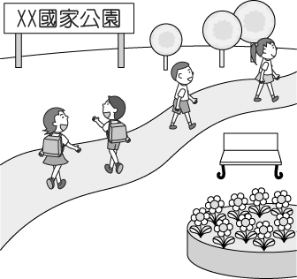 | (A) T | (B) F
2. | 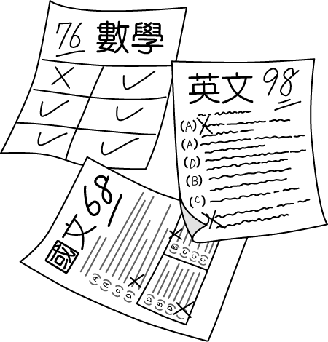 | (A) T | (B) F
3. | 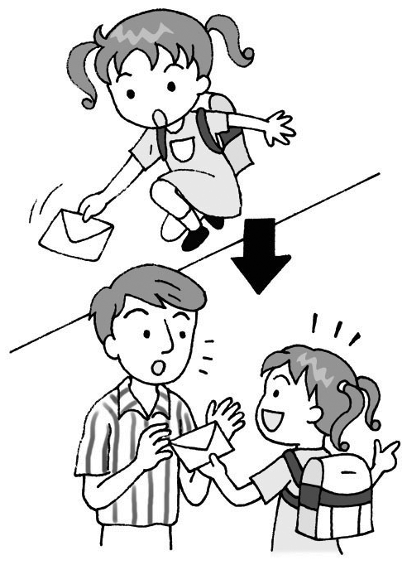 | (A) T | (B) F
4. | 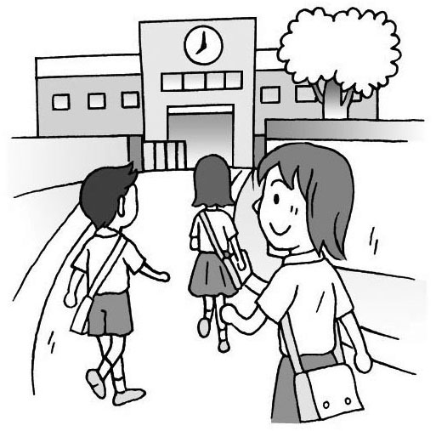 | (A) T | (B) F
5. | 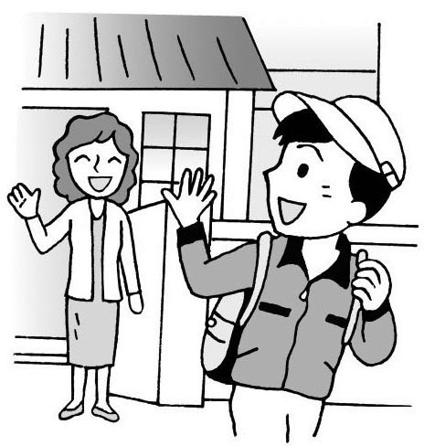 | (A) T | (B) F
- 根據聽到的句子，選出適當的圖片
6. | (A) | 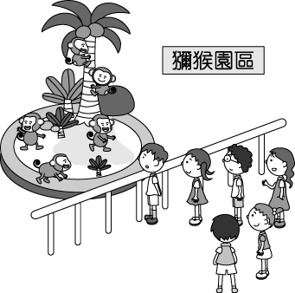 | (B) | 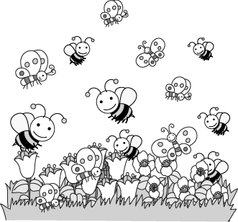
7. | (A) | 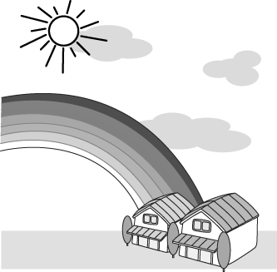 | (B) | 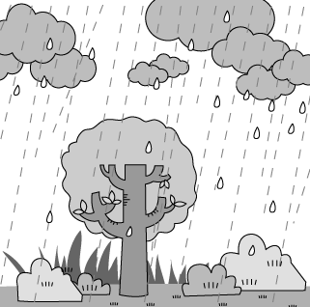
8. | (A) | 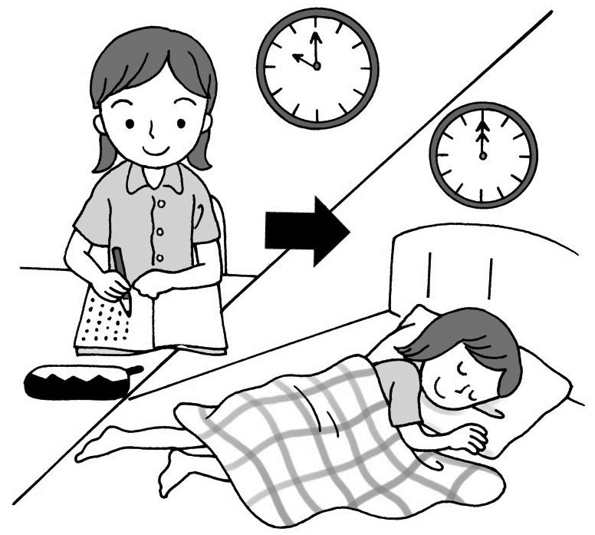 | (B) | 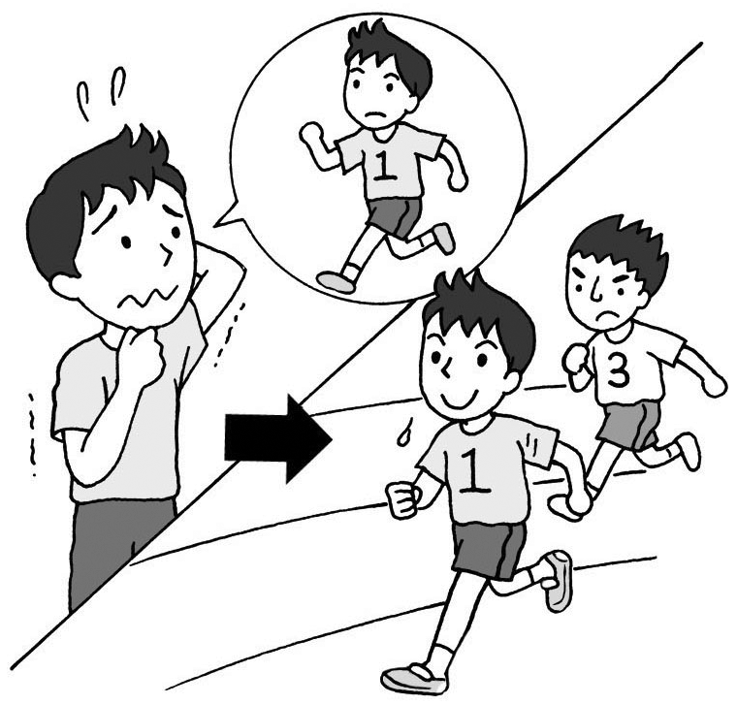
9. | (A) | 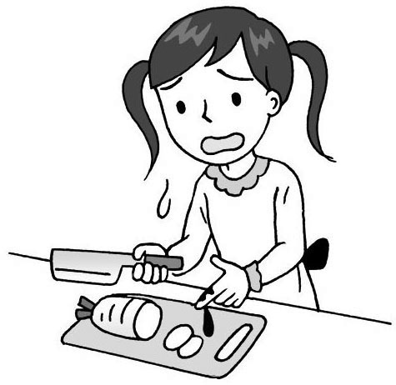 | (B) | 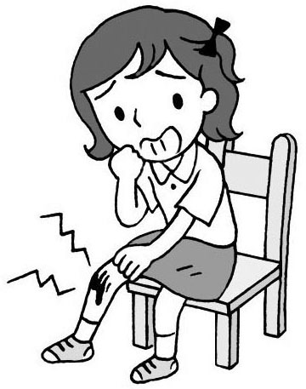
10. | (A) | 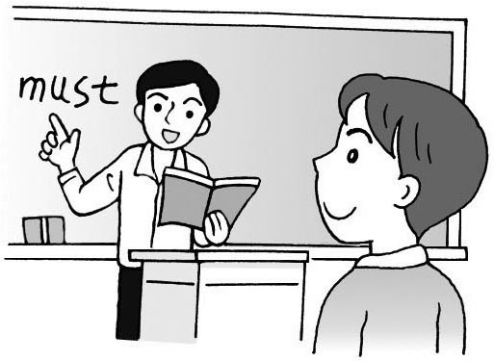 | (B) | 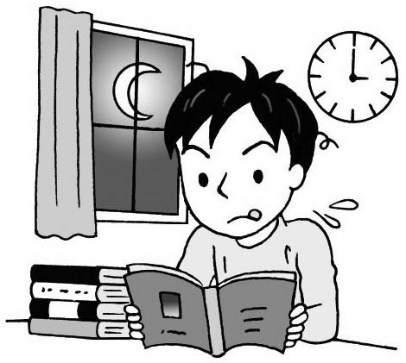
- 根據聽到的內容，選出最適當的回應句
11. | (A) Don’t forget to bring a map along.  (B) It’s about three miles, I think.
12. | (A) I think so too.  We should come here more often.  (B) Yes. The air is getting worse.  Perhaps we should call the EPA.
13. | (A) I studied very hard, but I still did badly on  the test.  (B) My friend sent me some funny pictures,  and I was looking at them.
14. | (A) I previewed and reviewed the lessons  every day.  (B) I was afraid of asking my English teacher  questions.
15. | (A) I feel a sharp pain in my head.  (B) See a doctor right away if you don’t feel  good.

第二部份：讀寫測驗（每題2分，共50分）
- 文法選擇
16. Is there an earthquake now?
I feel the building ______.
(A) will shake (B) shaking
(C) to shake (D) shakes
17. It rained ______ today than yesterday.
(A) heavy (B) heavier
(C) heavily (D) more heavily
18. Let’s walk along the beach and watch the sun
______ down.
(A) go (B) goes (C) went (D) was going
19. Sandy cooks Chinese food ______ than Japanese
food.
(A) good (B) well (C) better (D) best
20. ______ a walk in the forest, and you can enjoy the
fresh air.
(A) Take (B) Taking (C) To take (D) Took
21. If you don’t know the meaning of a new word,
______ in the dictionary.
(A) look at it (B) look for it
(C) look up it (D) look it up
22. Jack swims ______ on his school team.
(A) fast (B) faster (C) the fastest (D) fastly
23. Mom washes the vegetables carefully ______ she
cooks them.
(A) after (B) although (C) before (D) so
24. Thank you so much ______ giving me those
cooking tips.
(A) because (B) for (C) to (D) with
25. The final ______ is coming. We have to study
harder from now on.
(A) tip (B) point (C) group (D) exam
26. Although they are not rich, ______ they still live
happily.
(A) and (B) but (C) or (D) X
27. He has many friends, ______ he often feels lonely.
(A) although (B) but (C) if (D) so
28. If the weather ______ nice this Saturday, we
______ on a picnic in the park.
(A) will be; will go (B) will be; go
(C) is; will go (D) is; go
29. Linda might not ______ come to school today
because she has a cold.
(A) be able to (B) able to
(C) is able (D) is able to
30. We ______ glad ______ hear the good news.
(A) are; to (B) are; of (C) will; to (D) will; of
31. Having good eating habits ______.
(A) are good for your body
(B) help you become thinner
(C) is important to everyone
(D) make you healthier
32. Nancy: Helen and I are going to a movie. ______.
Emma: Sure. I love movies.
(A) Are you busy today?
(B) Do you like him?
(C) Do you want to join us?
(D) How can we go there?
33. Ken: Tomorrow is a holiday. Let’s visit the zoo.
Tom: ______, but I have to stay home to take care
of my younger sister.
(A) I’d love to (B) I don’t have time
(C) Let’s meet at nine (D) That’s too bad
34.William: I can’t go dancing with you tonight.
Kate: ______
William: I hurt my knee.
(A) Sounds nice. (B) That’s right.
(C) When? (D) Why not?
35. When you are tired or in pain, ______.
(A) because you need more exercise
(B) so you should take a rest
(C) though you are healthy and strong
(D) your body is trying to tell you something
- 題組
Mom: Mark, how was your school today?
Mark: It was terrible. 36
Mom: What 37 ?
Mark: I woke up too late this morning. 38 I
arrived at the bus stop, I saw my bus 39
away. I missed the bus and didn’t get to my first
class 40 time.
Mom: Was your teacher angry?
Mark: Yes, and she told me not to be late again.
Then, after I sat down, I found my math quiz on
the desk. I couldn’t believe that I failed it. I
was so sad.
Mom: My poor boy.

36. (A) I’m so happy today.
(B) Today is my lucky day.
(C) Today isn’t my day.
(D) What a wonderful day today.
37. (A) happen (B) happens
(C) happening (D) happened
38. (A) Although (B) Because (C) If (D) When
39. (A) driving (B) drives (C) drove (D) to drive
40. (A) with (B) in (C) for (D) at
How do you feel today? Are you satisfied with your life? In fact, more and more people get depressed because there is much unhappiness in their lives.
Here are some tips to be happy.
1. When you have some troubles and worries, you should always look at the bright side. Never feel sad. Just be happy.
2. Be thankful for what you have. When you are complaining about not having beautiful shoes, think about those with no legs.
3. Try your best to help people in need. Being a volunteer to help the poor and the elderly is a good way for you to cherish what you have.

satisfied滿意的／unhappiness不幸福
thankful滿懷感謝的／complain抱怨／
volunteer自願者／the elderly老年人／cherish珍惜
41. Which one is the best title for this article?
(A) How to Be Rich
(B) How to Help Others
(C) Tips for Being Happy
(D) Tips for Getting into Trouble
42. What does the word depressed mean?
(A) Bright. (B) Busy.
(C) Interesting (D) Unhappy.
43. According to this article, what can’t make us
happy?
(A) Looking at the bright side.
(B) Buying more expensive things.
(C) Being a volunteer to help people in need.
(D) Being satisfied with what we have.
For students had a competition to see who is better at sports. Look at the table and answer the questions.
 | David | Lisa | Mandy | Nick
High  Jump | 78 cm | 68 cm | 78 cm | 80 cm
Long  Jump | 128 cm | 116 cm | 126 cm | 125 cm
100-meter  dash | 10.45  seconds | 13.09  seconds | 12.24  seconds | 11.36  seconds

competition競賽／table表格／high jump跳高
long jump跳遠／100-meter dash百米賽跑
44. How far did Nick jump?
(A) 116 cm. (B) 125 cm.
(C) 126 cm. (D) 128 cm.
45. Who jumped as high as Mandy?
(A) David. (B) Lisa. (C) Nick. (D) No one.
六、英文諺語
46. 留得青山在，不怕沒柴燒
(A) A good conscience is a safe pillow.
(B) Don’t teach your grandmother to suck eggs.
(C) He who has health has hope.
(D) The pot called the kettle black.
47. 旁觀者清
(A) A rolling stone gathers no moss.
(B) Don't quarrel with your bread and butter.
(C) Lookers-on see most of the game.
(D) There’s a black sheep in every flock.
48. 防微杜漸
(A) A stitch in time saves nine.
(B) Much coin, much care.
(C) Practice makes perfect.
(D) There’s no rose without a thorn.
49. 勿以一概全
(A) After a storm comes to a calm.
(B) One swallow does not make a summer.
(C) Pride goes before a fall.
(D) There are two sides to every question.
50. 舌劍利於刀劍
(A) Ambition makes people diligent.
(B) Rome was not built in a day.
(C) Well begun is half done.
(D) Words cut more than swords.

