99學年度 台南縣立新東國中 八年級第一次段考 英語第三課-第五課
班級 座號 姓名
Part I: 聽力測驗 (共20％)
一、聽CD的兩個敘述，選出正確的代號。(每題一分：5％)

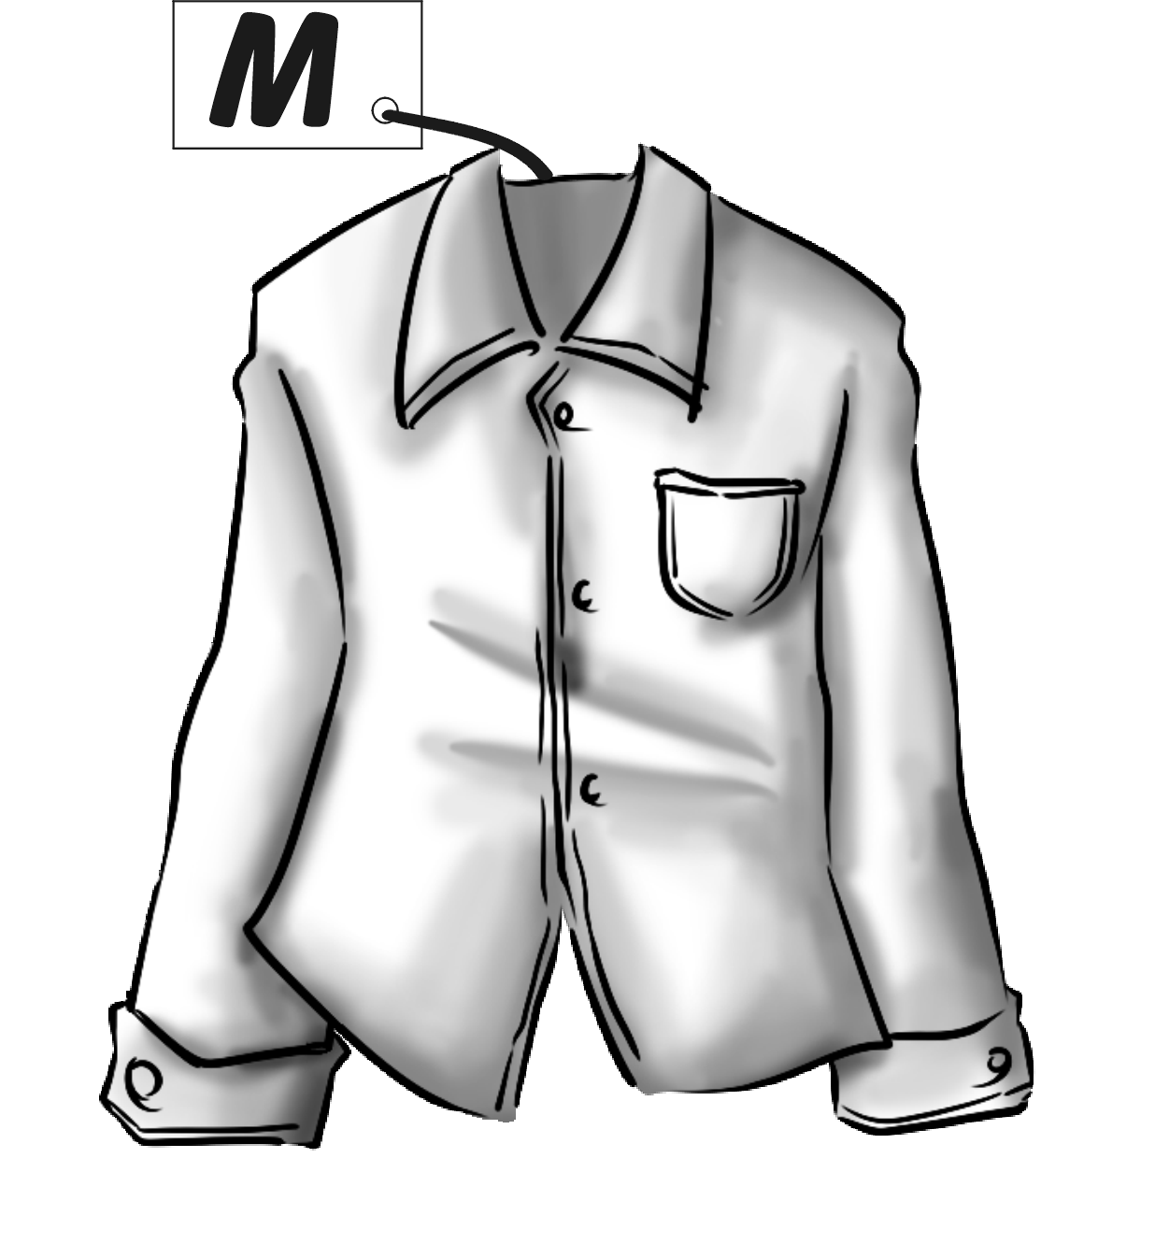
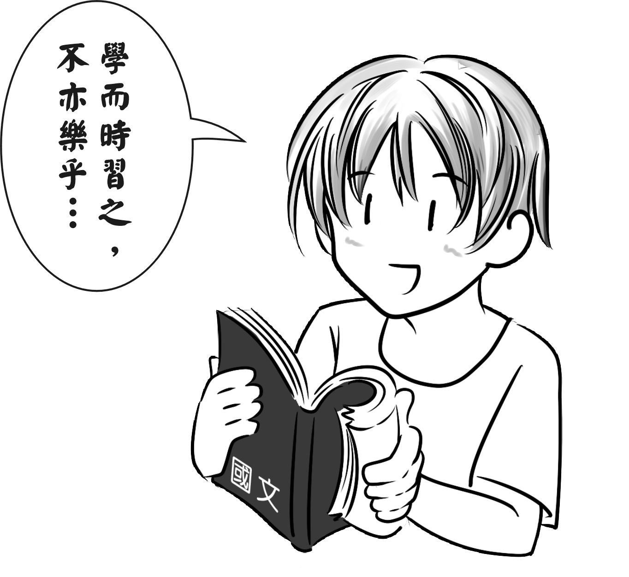
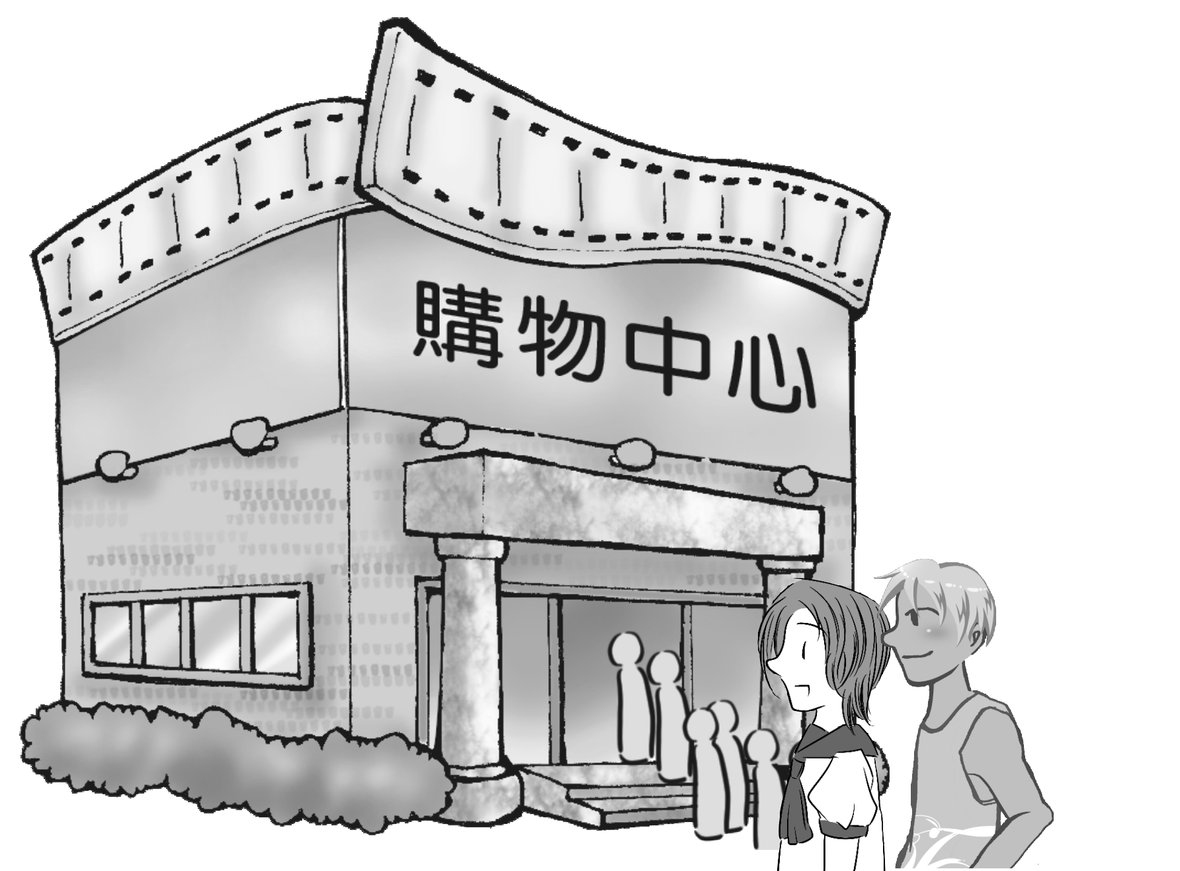
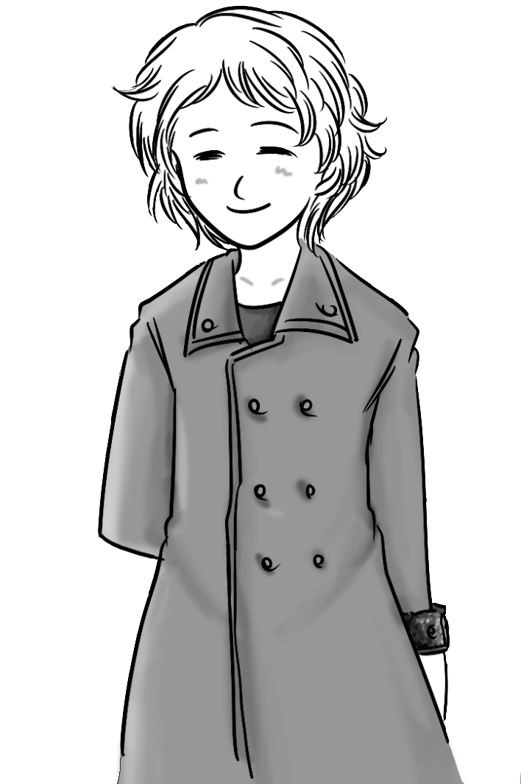
1. 2 3 4 5
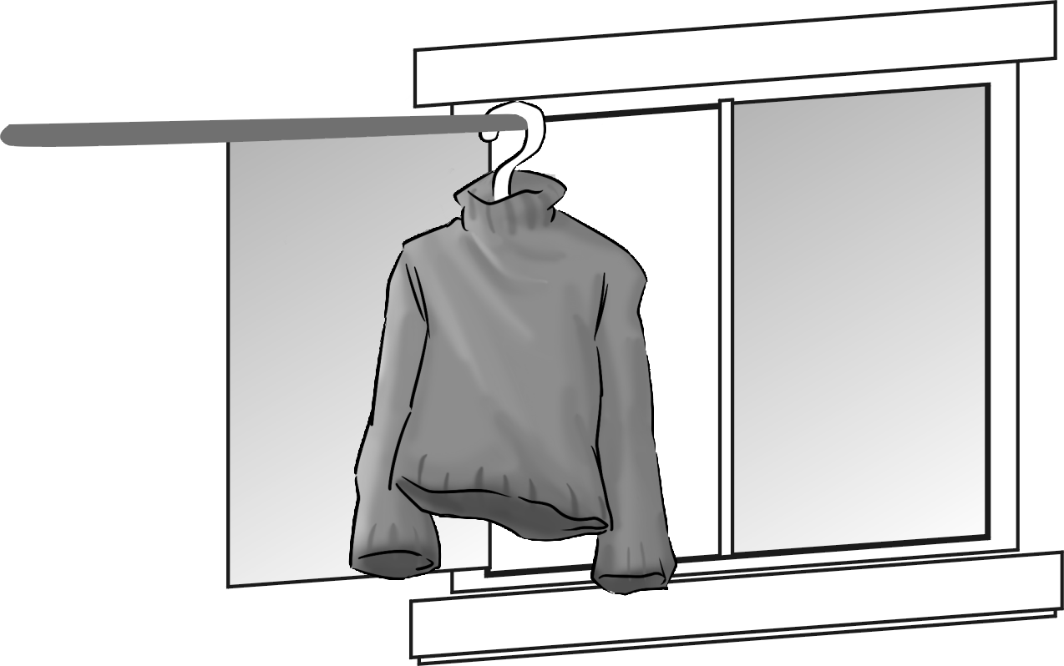

A B A B A B A B A B
二、聽CD的問題，選出最適當地回應。(每題一分：5％)
( ) 1. (A) I go fishing every day. (B) I work for a long time.
(C) I enjoy the view there. (D) I ride my bike.
( ) 2. (A) She looks tired. (B) She looks at the moon.
(C) She is not mean at all. (D) Her face will turn red.
( ) 3. (A) Because it’s a car with feelings. (B) Because it’s on the road.
(C) Because my car looks old. (D) Because it’s not my car.
( ) 4. (A) He went there by boat. (B) He went there once or twice a month.
(C) Because he is able to speak Chinese. (D) Because he had to go there on business.
( ) 5. (A) Because he took the plane at ten. (B) Because he didn’t call her last night.
(C) Because she is slow. (D) Because she is smiling at him.
三、聽CD的問題，選出最適當地回應。(每題一分：5％)
( ) 1. (A) Because she turned right at the next corner. (B) Because she was mean.
(C) Because Bob was mean to her. (D) Because she smiled at me.
( ) 2. (A) He rides his motorcycle. (B) He doesn’t go to work every day.
(C) He went by car. (D) He gets on it with his bike.
( ) 3. (A) From my house to my school. (B) Twice a month.
(C) On every Friday. (D) I seldom take the bus.
( ) 4. (A) Last December. (B) Yesterday morning.
(C) Four days ago. (D) On December 24th.
( ) 5. (A) She isn’t going to invite me. (B) Her good friend, Sally.
(C) She doesn’t like to play tennis. (D) Her uncle wasn’t a tennis player.
四、聽CD的兩個敘述，選出正確的代號。(每題一分：5％)
1.( )A: The man wants to catch the bus.
B: The man wants to run after the bus.
2. ( ) A: The woman kicked Claire.
B: Claire kicked the woman.
3. ( ) A: The plan sounds great.
B: The plan sounds terrible.
4. ( ) A: The woman walks slowly.
B: The woman walks fast.
5. ( ) A: The woman knows the answer.
B: The woman doesn’t know the answer.

Part II: 一、單字 15％
1.軍人 ____________________ 2.南瓜 ______________________ 3.結束 __________________
4.律師 ____________________ 5.服飾店 ________________________________
6.___________________ Let’s d e the Christmas tree!
7.___________________ Why is the machine making funny s ds?
8.___________________ I think the color is p e. It’s between red and blue.
9.___________________ Don’t ride so f t! It’s very dangerous!
10.___________________ The man was bad, and the policemen c t him.
11.___________________ What is your s e? 42 or 43?
12.___________________ I am only 16. I can’t ride a m e.
13.___________________ It’s cold. We have to put on our s rs.
14.___________________ B h of Eric’s parents are dentists.
15.___________________ Will we be a e to use the costume next year?
二、選擇 40％
1.( ) The traffic is heavy on Sundays, so we are sometimes traffic a long time.
(A) at (B) on (C) in (D) of
2.( ) Simon is an _____________ person. He gets excited _______.
(A) interesting; easy (B)interested; sad (C)interesting; easily (D)interested; sadly
3.( ) It’s snowing . You have to drive .
(A) heavy ; careful (B) heavily ; carefully (C) heavily ; careful (D) heavy ; carefully
4.( ) Alice usually a phone call and asks about our homework.
(A) takes (B) makes (C) calls (D) plays
5.( ) I saw Tina’s brother the car.
(A) of (B) in (C) by (D) on
6.( ) John looked __________ at the party.
(A) happy (B) happily (C) me (D) mine
7.( ) Mary usually gets on the ferry her scooter.
(A) with (B) and (C) by (D) in
8.( ) These koalas in the zoo are cute. I like very much.
(A) ones (B) them (C) their (D) theirs
9.( ) Bill is in a hurry, so he has to go to work taxi.
(A) with (B) on (C) by (D) in
10.( ) We have to go quickly. There are other places visit.
(A) to (B) for (C) in (D) with
11.( ) Their house has a yard. You can play basketball there.
(A) small (B) large (C) medium (D) sunny
12.( ) My little brother is so _________. We all want to play with him.
(A)like (B)likely (C)love (D) lovely
13.( ) Amy is smiling her new friend, Julie.
(A) from (B) above (C) at (D) on
14.( ) Cindy: Which boy is your brother?
Alex: in a funny T-shirt.
(A) One (B) The one (C) The other (D) Another
15.( ) Peter: My job is boring!
David: But is interesting!
Peter: Really? What do you do?
(A) mine (B) my (C) me (D) it
16.( ) Peter: Do you have a computer?
Bill: Of course I have .
(A) one (B) ones (C) it (D) they
17.( ) Alice: Is this Jack’s jacket?
Helen: Yes, I think it’s .
(A) he’s (B) her (C) hers (D) his
18.( ) Wendy: How often do you go back to New York?
Laura:
(A) I always go home by train.
(B) I will go there by plane.
(C) My brother is going to go back with me.
(D) Once a month.
19.( ) Mike: Whose houses are these?
Ted: They are .
(A) the Wang (B) the Wangs (C) the Wang’s (D) the Wangs’
20.( ) Tony: do you like?
Ben: I like basketball because I can play it with my classmates at school.
(A) Which sport (B) Whose (C) Whose sport (D) Who

三、閱讀測驗 10％
Yesterday was a terrible day.
It all started in my bedroom in the morning.
I didn’t wake up myself; my mother woke me up –
three times! Then I couldn’t find a matching pair
of socks, so I had to put on one black sock and one white one – one was long the other was short.
In the dining room, I found I had to eat cereal for breakfast because there was no more toast.
Yuck! I don’t like cereal! It was already a terrible day!
Because I don’t like cereal, I ate very slowly.
And because I ate slowly, we left home late, and my father was angry at me. He had to drive me to school, so he was late for work. The second class of the day was computer class, and of course I had to take my shoes off… All the boys laughed at my socks, and I felt very embarrassed. It was really a terrible and bad day!
 wake up 使起床 myself 我自己 could（can的過去式）能 match 相配 leave 離開 take off 脫掉 laugh 笑

1.( ) Why was the writer’s father angry at him?
(A) Because the writer woke up three times.
(B) Because the writer had to go to school early.
(C) Because the writer put on the wrong socks.
(D) Because the writer ate cereal slowly.
2.( ) What happened yesterday?
(A) The writer put on two long, black socks.
(B) The boys laughed at the writer.
(C) The writer was late for computer class.
(D) The writer ate toast for breakfast.
3.( ) What does “embarrassed” mean?
(A) Hungry and thirsty.
(B) Tired and angry.
(C) Terrible and nervous.
(D) In a hurry.

Easter
Easter Sunday is one of the most important holidays for Christians. It is always in spring on a Sunday between March 22 and April 25. It is always on a different date each year. Easter Sunday was on April 11 this year. On Easter Sunday in the US, people often paint eggs in bright colors and hide them in a park for children to find. Children in every city enjoy the Easter egg hunt. Eggs are a symbol of new life. Many people go to church on Easter Sunday. They thank God for the new life he gives to the world. After going to church, families often get together and enjoy a big Easter dinner.
Christian 基督徒 hide 藏起來 church 教堂 hunt 搜尋 symbol 象徵 life 生命
4.( ) Where do people go on Easter Sunday?
(A) To school. (B) To the theater. (C) To church. (D) To a hospital.
5.( ) Which one is true about Easter Sunday?
(A) Children put the eggs on the ground for their parents to hunt.
(B) It is a holiday all over the world.
(C) It is always on Saturday or Sunday.
(D) Christians thank God for the new life he gives to the world.

四、依提示作答 8％
- He goes to work by bus.（用 take 改寫）
___________________________________________________________________
- They will go to Taipei by train.（依據畫線部份造原問句）
___________________________________________________________________
- The nurse was late for work today.（用 went 改寫）
___________________________________________________________________
- David is a hard worker. （請將劃線部份改為副詞並重寫）
___________________________________________________________________

五、翻譯 7％
她必須搭渡輪橫越高雄港去工作。
2% 1.___________________________________________________________________
然後她在客廳到處追他，而且他們兩人都叫的很大聲。
2% 2.___________________________________________________________________
Sandy，快一點！我們上學要遲到了，而且我們也不能錯過我們的考試！
3% 3.___________________________________________________________________

台南縣立新東國中 八年級第一次段考 英語第三課-第五課 答案卷
班級 座號 姓名
聽力測驗 (共20％)
一、(每題一分：5％) 聽CD的兩個敘述，選出正確的代號。
1 | 2 | 3 | 4 | 5
二、(每題一分：5％) 聽CD的問題，選出最適當地回應。
1 | 2 | 3 | 4 | 5
三、(每題一分：5％) 聽CD的問題，選出最適當地回應。
1 | 2 | 3 | 4 | 5
四、(每題一分：5％) 聽CD的兩個敘述，選出正確的代號。
1 | 2 | 3 | 4 | 5
綜合測驗 (共80％)
一、單字 15％
1 | 2 | 3 | 4 | 5
6 | 7 | 8 | 9 | 10
11 | 12 | 13 | 14 | 15
二、文法選擇 40％
1 | 2 | 3 | 4 | 5
6 | 7 | 8 | 9 | 10
11 | 12 | 13 | 14 | 15
16 | 17 | 18 | 19 | 20
三、閱讀測驗 10％
1 | 2 | 3 | 4 | 5
四、依提示作答 8％ (錯一個部份全錯，注意時態和名詞單複數)
1.___________________________________________________________________
2.___________________________________________________________________
3.___________________________________________________________________
4.___________________________________________________________________
五、翻譯 7％
2% 1.___________________________________________________________________
2% 2.___________________________________________________________________
3% 3.___________________________________________________________________

台南縣立新東國中 八年級第一次段考 英語第三課-第五課 答案
聽力測驗 (共20％)
- (每題一分：5％) 聽CD的兩個敘述，選出正確的代號。
CD內容： 1. A: There is a sweater near the window. B: There is a dress near the window.
2. A: That shirt is medium. B: That shirt is large.
3. A: Nick did well on the Chinese exam. B: Nick studied for a Chinese exam.
4. A: They walked to the mall one by one. B: They drove to the mall together.
5. A: The yellow coat will look good on your mom. B: The pink shirt will look good on your mom.
1 | 2 | 3 | 4 | 5
A | A | B | A | A
二、(每題一分：5％) 聽CD的問題，選出最適當地回應。
CD內容：1. How do you go to school? 2. How does Susan look?
3. Why do you want to buy a new car? 4. Why did John go to Beijing last week? 5. Why is Lisa angry with Ryan?
1 | 2 | 3 | 4 | 5
D | A | C | D | B
三、(每題一分：5％) 聽CD的問題，選出最適當地回應。
CD內容： 1. Why did Irene sound angry on the phone? 2. How does David go to work?
3. How often do you go to school by taxi? 4. When will you give a Christmas party? 5. Who is Marylyn going to play tennis with?
1 | 2 | 3 | 4 | 5
C | A | B | D | B
四、(每題一分：5％) 聽CD的兩個敘述，選出正確的代號。
CD內容：
1. (M): Why is that man running so fast? (F): He wants to catch the bus.
2. (M): Who kicked you? (F): Claire did.
3. (M): Does the plan sound great? (F): Well, it sounds terrible.
4. (M): Do you walk fast? (F): No, I’m a slow walker.
5. (M): Do you know the answer to the question? (F): No, the question is hard for me.
1 | 2 | 3 | 4 | 5
A | B | B | A | B
綜合測驗 (共80％) 一、單字 15％
1 | 2 | 3 | 4 | 5
soldier | pumpkin | end | lawyer | clothing store
6 | 7 | 8 | 9 | 10
decorate | sounds | purple | fast | caught
11 | 12 | 13 | 14 | 15
size | motorcycle | sweaters | Both | able
二、選擇 30％
1 | 2 | 3 | 4 | 5
C | C | B | B | B
6 | 7 | 8 | 9 | 10
A | A | B | C | A
11 | 12 | 13 | 14 | 15
B | D | C | B | A
16 | 17 | 18 | 19 | 20
A | D | D | D | A
三、克漏字與閱讀測驗 20％
1 | 2 | 3 | 4 | 5
D | B | C | C | D
四、依提示作答 8％
1. He takes the(a) bus to work.
2. How will they go to Taipei?
3. The nurse went to work late today..
4. David works hard.
五、翻譯 7％
2% 1. She has to take the ferry x1 across Kaohsiung Harbor to work.x1
2% 2. Then she chased him around the living room,x1 and they both shouted noisily.x1
3% 3. Sandy, hurry up!x1 We are going to(will) be late for school,(We will go to school late,)x1
and we can’t miss our test!x1

