高雄市立光華國民中學99學年度第1學期第2次段考三年級英文科試題
班 號 姓名

一、聽力測驗：20%
(一) 聽CD，配合圖片選出最適當的答案：5%
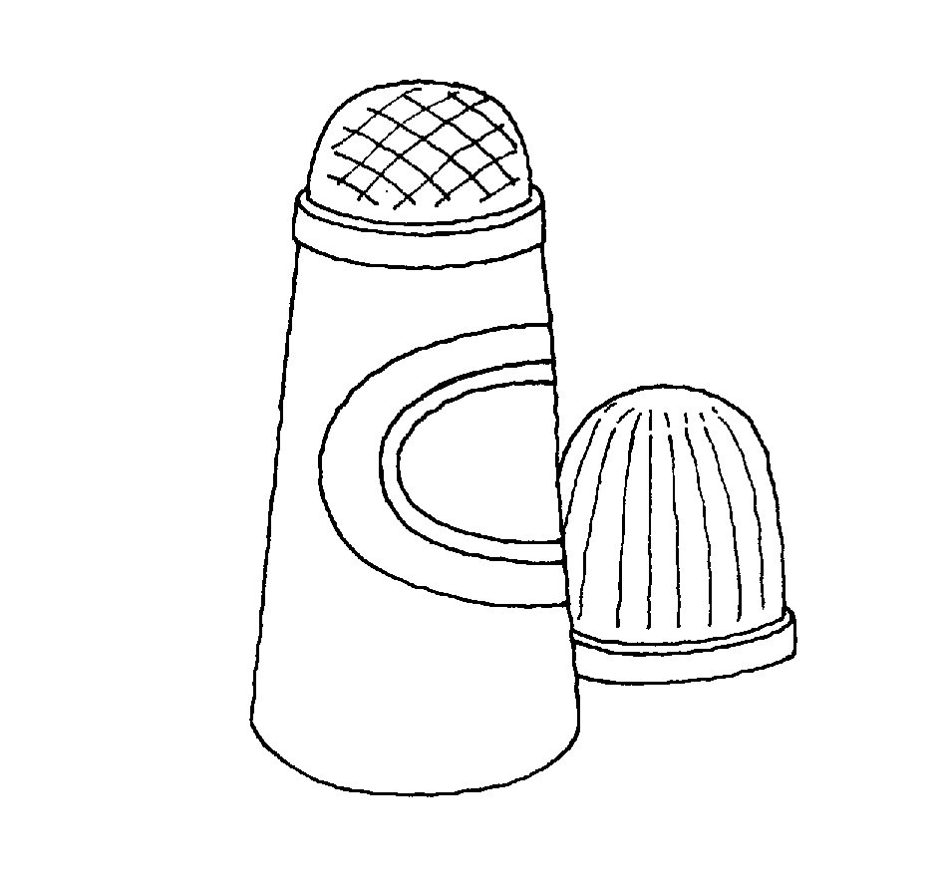
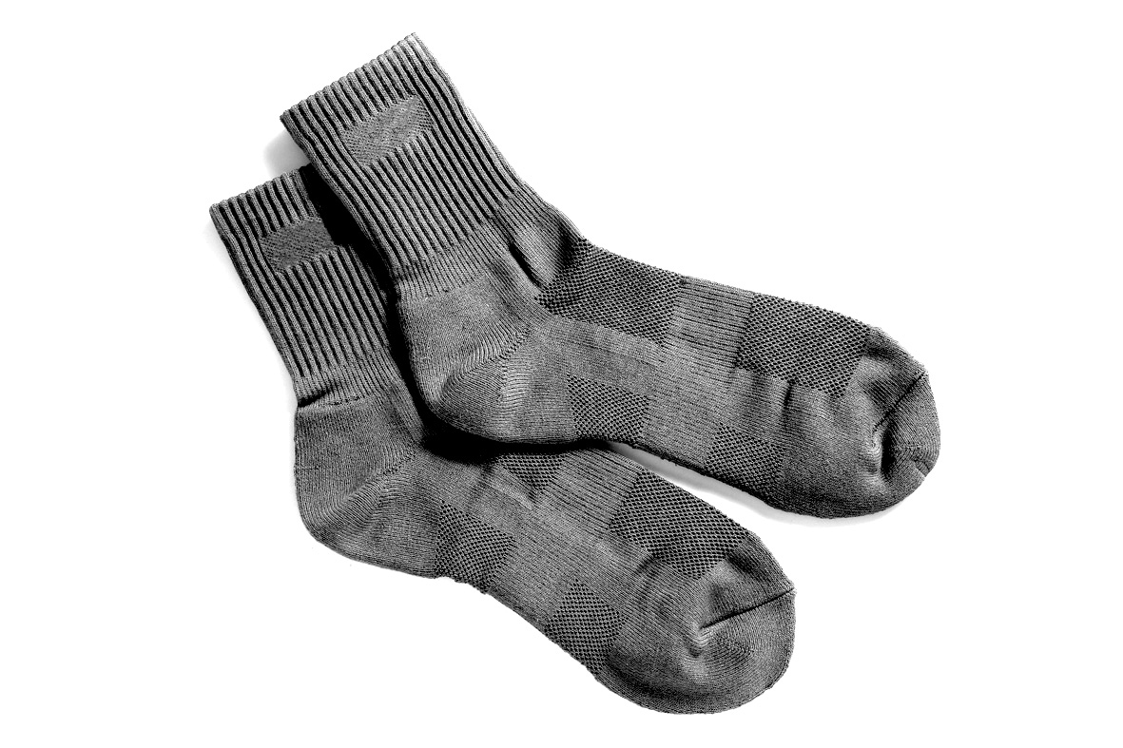
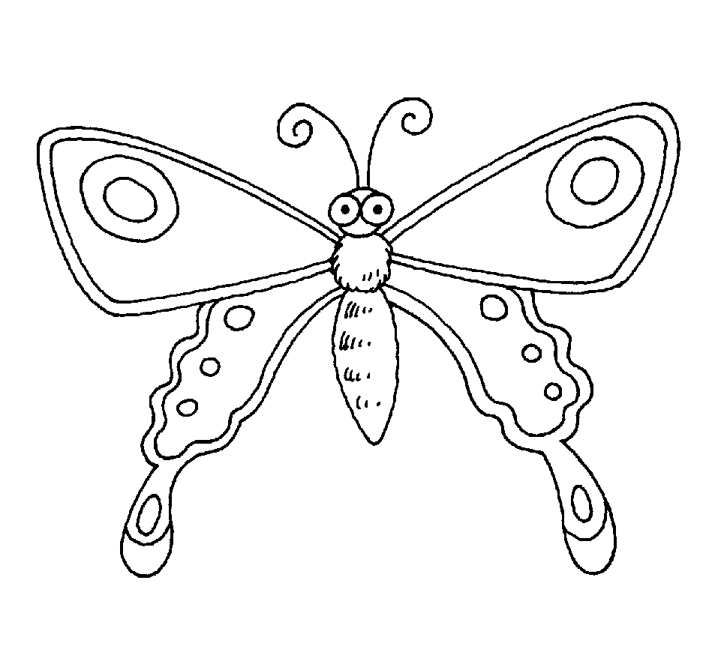
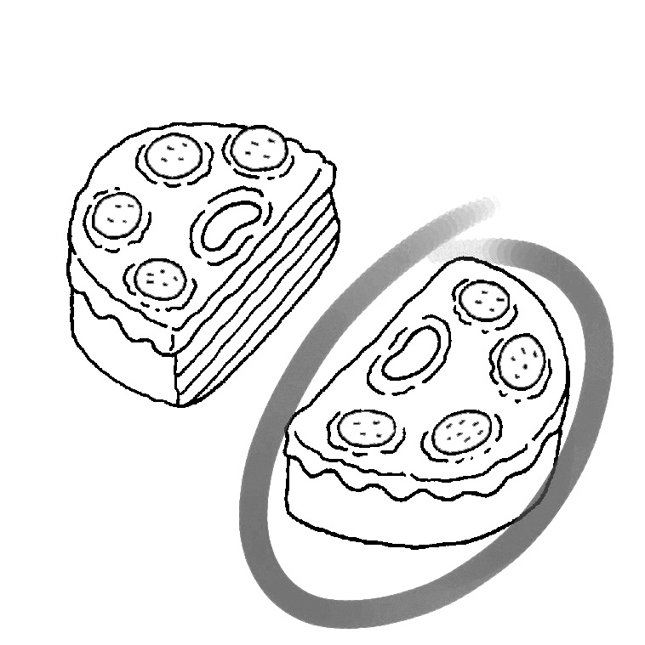
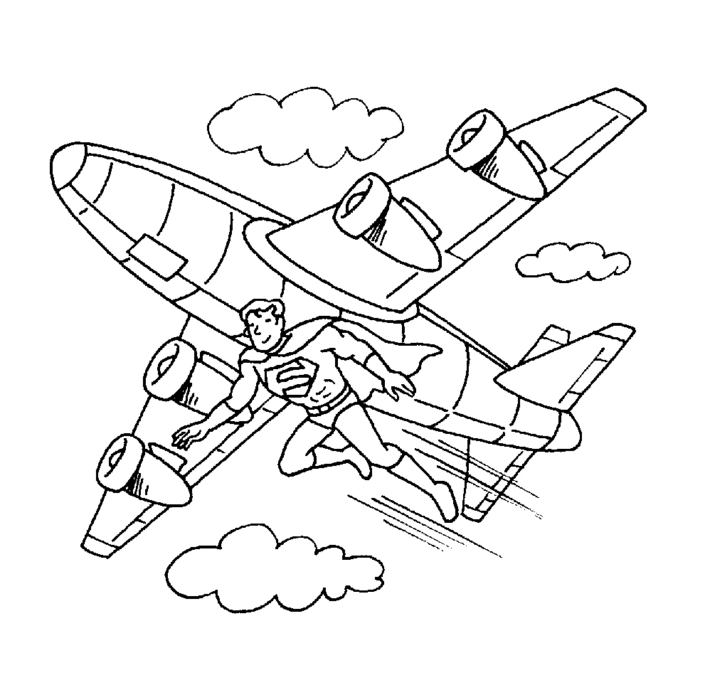
1. 2. 3. 4. 5.

(二) 聽CD，選出最適當的答案：10%
1. (A) The woman’s friend. (B) The man’s friend.
(C) Sandy’s uncle. (D) Charles’ uncle.
2. (A) Women and pants. (B) Women in the 70s.
(C) Women and work. (D) Women and restaurants.
3. (A) He made up his mind to travel in Africa. (B) He plans to help sick children in Africa.
(C) He decided to give money to poor people. (D) He wants to dig wells for people in America.
4. (A) Fewer than nine robots. (B) More than five hundred dollars.
(C) Less than three hundred dollars. (D) Less than four hundred dollars.
5. (A) On the boy’s book. (B) On her own book.
(C) On her friend’s desk. (D) On the boy’s dictionary.

(三)聽CD，寫出正確的答案：5%
1. The workers are not allowed to go out during the hours.
2. My sister always wears something when she goes out.
3. Students like to play bingo because it is a game.
4. The fishermen caught a fish in the sea.
5. David all the words right in the sentence.

二、文意字彙：20%
1. Uncle Ben has been a worker in a car f y for twenty years. He has many cars to fix every day.
2. Make use of the ruler to help you draw a s t line, Peter.
3.When there is a fire, fire fighters need to take a n to deal with it.
4. Swimming in the river is more dangerous than swimming in the p l.
5. Guide dogs are trained(訓練) to help the b d people to walk safely on the street.
6. The story about Ryan’s well project a red in all the newspapers in Canada. So lots of people began to notice this special boy and tried to send him money.
7. Mom likes to p e her shopping list or daily schedule(行程表) on the refrigerator.
8. When you study, remember to prepare a red pen to m k the key points.
9. If you don’t know the meanings of the words, try to look them up in the d y.
10. Please don’t p l others’ hair because it will hurt and it is not polite.

三、填入適當的介系詞代號: 10%
(A) in (B) on (C) of (D) off (E) with (F) about
1. James: Do you see that special basketball player over there? Philips: Which one?
James: The one long curly(捲曲的) hair.
2. Mr. and Mrs. Wang have three kids, so they hope to find a house four bedrooms and a big garden.
3. In some western countries, people T-shirts or shorts are not welcome in fine restaurants.
4. The magazine National Geography many beautiful pictures of elephants is little Johnny’s favorite.
5. In Discovery Channel(頻道), people can watch some interesting TV programs wild(野生的) animals.
6. Though Ryan was just a little kid, however, he still tried hard to help people in Africa. His parents were really
proud him.
7. The bell-bottoms and the mini skirts were quite popular the 1980s.
8. This type of computer that comes in several colors is the latest style the market.
9. George can play basketball very well now because he practiced it two hours a day the past five years.
10. In Japan, people take their shoes before entering a house.

四、綜合測驗：30%
1. Since (因為) the bridge was broken, it took the villagers(村民;鄉民) a lot of time the river.
(A) cross (B) crossing (C) crossed (D) to cross
2. Jimmy a walk along the country road after dinner. But he doesn’t do it anymore after a serious car
accident. (A) uses to take (B) used to take (C) used to taking (D) is used to take
3. Teenagers had better a motorcycle before they have a driver’s licence (執照).
(A) not riding (B) not to ride (C) not ride (D) don’t ride
4. Jean: What happened to the dog on the street?
May: A car just ran over (輾過) it and it soon.
(A) died (B) dead (C) has been dead (D) has died
5. Amy: I heard you went to see the musical play “Cats” yesterday. How was it?
Cathy: The show was really excellent, but the ticket to the show me NT$ 4000. It was very expensive.
(A) spent (B) took (C) paid (D) cost
6. Frank: Why did you keep looking outside this morning? Grdg: I thought I saw next to our house.
(A) something strange (B) strange something (C) some strange thing (D) some things strange
7. Many parents don’t want their children to read .
(A) such a scared story (B) so scared a story (C) such a scary story (D) such scary a story
8. In the story Three Little Pigs and the Big Bad Wolf, the three little pigs were asked by their mother to build
their own houses. One of them wanted to build a house of straw(稻草), wanted to build a house of
wood(木頭), and wanted to build a house of bricks(磚塊).
(A) the other, the other (B) another, another (C) the other, another (D) another, the other
9. After the Taiwan High Speed Rail(高鐵) system is built, people take planes to Taipei. The reason is
that people can pay money to take the THSR and don’t have to waste lots of time checking in.
(A) less, fewer (B) fewer, less (C) more, less (D) more, fewer
10. Nina: Do you have the book The Twilight Saga: New Moon? Can I it you?
Diane: Sure. I can mine you.
(A) borrow, to; lend, from (B) borrow, from; lend, to (C) lend, to; borrow, from (D)lend, from; borrow, to

11. The bears in the North Pole are in great danger now because of the global warming.
(A) who lives (B) who live (C) which live (D) that lives
12. The sofa was bought by my grandmother.
(A) you are sitting on ((B) which you are sitting (C) that you are sitting (D) on that you are sitting
13. Do you know the boy and his dog are playing happily on the playground?
(A) whose (B) who (C) which (D) that
14. Jay Chou, writes many popular songs, also becomes the host(主持人) of a TV show now.
(A) whose (B) who (C) which (D) that
15. Mr. White is the person .
(A) who they are talking (B) who we have known him for three years.
(C) who can dance and sing very well (D) who always help people in need.

五、閱讀測驗：10%
(一)

A wishing well is usually a small well with a little water in it. People throw coins in the wishing well and make a wish. They hope that throwing coins in the well will make their wish come true.
One wishing well is different from most because it is a big wishing well in the Luray Caverns in Virginia. Thousands of visitors come to this huge wishing well, make a wish, and then throw in a coin or two. The well is so big, and so many visitors fling coins into it, that the bottom is almost always covered with money－sometimes thousands of dollars！ The money is later collected and given to organizations of people who are looking for new medicines and new cures for diseases.

coin 錢幣 organization 組織 cure 治療 disease 疾病

1. The word “fling” in the second paragraph(段落) means .
(A) to buy (B) to make (C) to throw (D) to find
2. The article(文章) tells us that the Luray Caverns are .
(A) dangerous (B) popular (C) very small (D) clean
3. The best title for this article is .
(A) How to Collect Money (B) Visiting Virginia
(C) Looking for New Medicine (D) A Huge Wishing Well
Skirts NT$ 1000 20% off
T-shirts NT$ 500 50% off
Vests NT$ 1200 20% off
Shorts NT$ 600 40% off
Jeans NT$ 1500 30% off
Ties NT$ 300 10% off
(二)
Clothes on Sale
Welcome to Bella’s Clothes Shop!
All kinds of clothes are on sale
from November 1st to November 15th.

4. Gina bought a pair of jeans in Bella’s Clothes Shop on November 6th. How much could she save?
(A) NT$ 45. (B) NT$ 540. (C) NT$ 450. (D) NT$ 1050.
5. Alice only brought five hundred dollars with her. What might she buy in Bella’s Shop?
(A) A skirt. (B) Two pairs of shorts. (C) Two ties. (D) Two T-shirts.
高雄市立光華國民中學99學年度第1學期第2次段考三年級英文科試題
班 號 姓名

一、聽力測驗：20%
(一) 聽CD，配合圖片選出最適當的答案：5%
1 |  | 2 |  | 3 |  | 4 |  | 5

(二) 聽CD，選出最適當的答案：10%
1 |  | 2 |  | 3 |  | 4 |  | 5

(三)聽CD，寫出正確的答案：5%
1 |  | 2 |  | 3 |  | 4 |  | 5

二、文意字彙：20%
1 |  | 2 |  | 3 |  | 4 |  | 5
6 |  | 7 |  | 8 |  | 9 |  | 10

三、填入適當的介系詞代號: 10%
1 |  | 2 |  | 3 |  | 4 |  | 5
6 |  | 7 |  | 8 |  | 9 |  | 10

四、綜合測驗：30%
1 |  | 2 |  | 3 |  | 4 |  | 5
6 |  | 7 |  | 8 |  | 9 |  | 10
11 |  | 12 |  | 13 |  | 14 |  | 15

五、閱讀測驗：10%
1 |  | 2 |  | 3 |  | 4 |  | 5

六、翻譯：10%
1. Helen Keller因為一場高燒而失去視力。
Helen Keller
2.便利貼在現代生活中扮演一個重要的角色。

3.他下定決心要募款去幫助非洲鑿井。
He help dig wells in Africa.
4. 換句話說,女人花了超過半個世紀才贏得穿褲子的權力。
, it took women to win the right to wear pants.
5.媽媽做給Sally的餅乾是愛心形狀的。
The cookies for Sally were .
高雄市立光華國民中學99學年度第1學期第2次段考三年級英文科試題解答
一、聽力測驗：20%
(一) 聽CD，配合圖片選出最適當的答案：5%
1~5 BADCA
(二) 聽CD，選出最適當的答案：10%
1~5 CABDB
(三)聽CD，寫出正確的答案：5%
1. office 2. fashionable 3. simple 4. giant 5. spelled
二、文意字彙：20%
1. factory 2. straight 3. action 4. pool 5. blind
6. appeared 7. paste 8. mark 9. dictionary 10. pull
三、填入適當的介系詞代號: 10%
1~5 EEAEF 6~10 CABAD
四、綜合測驗：30%
1-5 DBCAD 6-10 ACDBB 11-15 CADBC
五、閱讀測驗：10%
1-5 CBDCD

六、翻譯：10% (每個段落1分)
1. Helen Keller lost her sight because of a high fever.
2. Post-it notes play an important part in modern life.
3. He made up his mind to raise money to help dig wells in Africa.
4.In other words, it took women more than half a century to win the right to wear pants.
5. The cookies (which/that) Mom made for Sally were in the shape of hearts.

